Toolbox Talk: The Cost of Assumptions – Lessons from a Gas Line Strike
Working near underground utilities is a high-stakes environment where "assuming" is the quickest way to cause an accident. Today, we’re reviewing a real-world incident that occurred and discussing how to prevent it from happening on our site.
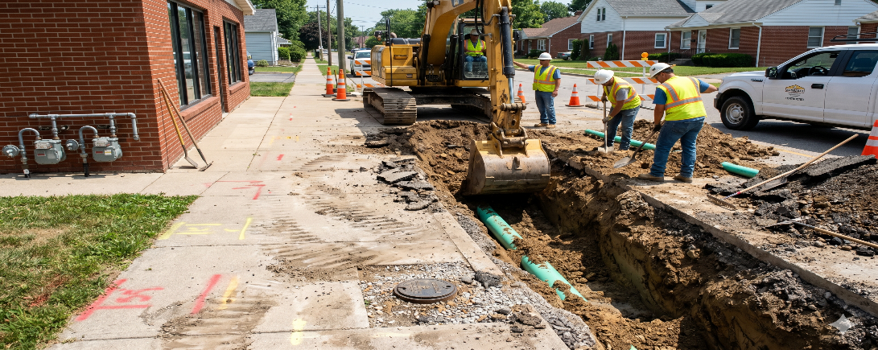
The Incident: A Case Study
A contractor was installing a sewer main and was fully aware that natural gas lines were in the vicinity. They could see gas meter sets and a valve box in the sidewalk. The area had been marked originally, but as the excavation progressed, the contractor’s own work destroyed all the utility markings.
Rather than stopping to have the lines re-marked, the contractor assumed the gas service ran in a straight line from the valve box to the center of the road. They chose to dig in an area they thought was safe. They were wrong. They struck and damaged the natural gas service line.

The Findings: What Went Wrong?

The regulatory authorities investigated the strike and determined the contractor was at fault for two primary reasons:
- Failure to Maintain Marks: It is the excavator's legal responsibility to preserve the integrity of the paint and flags.
- Failure to Request Re-marks: Once the contractor realized the marks were gone and they no longer knew the exact location of the gas service, they were legally required to stop and call for a re-mark.

Virginia Law & Your Responsibility

In the Commonwealth, the Virginia Underground Utility Damage Prevention Act is clear. Following these rules isn't optional; it's the law.
- Respect the Marks: If you know you are digging in an area with utilities, you must take every precaution to protect the marks. If site conditions or your own excavation destroy them, you must stop work.
- The 48-Hour Rule: When marks are lost, you must contact Virginia 811 for a "Remark" ticket. You must wait the required 48 hours for utilities to respond before resuming excavation in that area.
- Never Assume: Utilities rarely run in a perfectly straight line. "Visual cues" like meters and valve boxes give you an idea of presence, but only valid 811 marks (and careful potholing) give you location.

Safe Digging Practices to Follow Today

- Verify Before You Dig: Check the Positive Response system to ensure all utilities have marked the area.
- Hand Dig in the Tolerance Zone: In Virginia, the tolerance zone is 24 inches on either side of the utility. Use blunt-nosed shovels or vacuum excavation to expose the line before using heavy machinery.
- Protect the Paint: Use offset markings or stakes if you know your excavation will destroy the primary paint lines.
- Stop the Job: If the marks are gone, or if the marks don't match what you see in the ground (e.g., you find a pipe where there are no marks), STOP and call it in.

Emergency Response: Gas Line Hits

If you hit a gas line, even if it just looks like a minor scratch to the coating:
- Shut Down: Turn off all equipment and eliminate potential ignition sources (no smoking, no cell phones near the leak).
- Evacuate Upwind: Evacuate the area immediately. Move upwind, ensuring the wind is hitting your face. Do not move downwind, as you will be following the path of the escaping gas.
- Call for Help: Notify 911 and the utility company immediately.
- Do Not DIY: Never attempt to repair the line or operate any utility valves yourself.

The Bottom Line: The contractor in this case knew the gas line was there, but they prioritized production over protocol. In Virginia, a "straight line" assumption can lead to a massive fine, a destroyed reputation, or a fatal explosion.
When the marks are gone, the digging stops!

