TOOLBOX TALK SAFE MATERIAL HANDLING
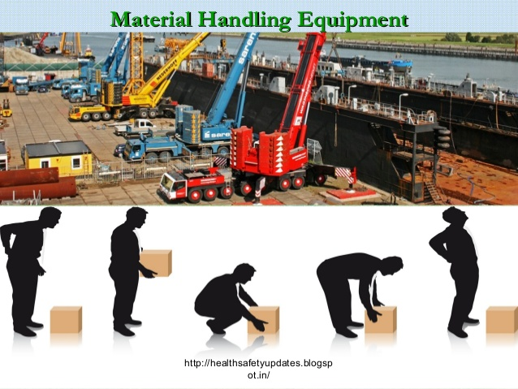

Manual Material Handling: Lift Smart… So You Can Walk Tomorrow
A surprising number of painful workplace injuries happen because someone forgot the basics of lifting, or thought they were secretly training for the Strongman Competition. Spoiler alert: you’re not. Let’s keep you in one piece.

First Things First: Dress Like You Like Your Toes
Personal Protective Equipment (PPE) isn’t optional fashion, it’s survival gear.
- Think of your toes. Gravity works every time. If something heavy drops, steel-toed boots turn a disaster into a loud noise instead of a hospital visit.
- Think of your hands. Gloves are your friends. Wear sturdy gloves when handling rough, sharp, or splintery materials. Bandages are not a substitute for gloves.

Before You Lift: Pause and Use Your Brain
- Test the load. Give it a nudge. If it feels like it’s filled with bricks… it probably is. Use team lifting or mechanical equipment for heavy or awkward loads. There is no prize for “Most Strained Back.”
- Get a solid grip. Your hands should be on the object, and nothing else. Coffee cups, phones, and hero complexes don’t belong in your hands while lifting.
And remember: strapping tape is not a handle.
- Check your footing. If you’re standing like a baby deer on ice, fix that first.
- Inspect your path. Make sure your route is clear. Debris and obstacles love surprise appearances.
- Check the packaging. Make sure the load is secure and won’t spill its contents mid-trip.

When You Lift: Your Back Is Not a Crane
- Keep the load close. The farther it is from your body, the harder your back works, and it already has enough to do.
- Overhead item? Use a ladder or lift. You are not Inspector Gadget.
- Don’t reach across pallets. Walk around it or turn it. If it’s light, slide it carefully, watch for shrink wrap or pallet edges that like to snag things.
- Crouch down. Keep the load between your legs and get a good grip.
- Lift smoothly with your legs. Slow and steady. Keep your back as vertical as possible.
- Face the load. Don’t twist your spine like you’re in a dance competition. Pivot your feet instead.
- Carry it between your shoulders and waist.
- Don’t block your view. If you can’t see where you’re going, neither can the accident.
- Avoid the “one more box” syndrome. That extra trip is cheaper than physical therapy.

Use the Tools, That’s Why We Bought Them
Dollies, carts, two-wheelers, hoists, and lifts are not decorations. Use them whenever possible. And if you’re moving something with a manual device:
- Push instead of pull. Your body will thank you later.

Bottom Line
Lift smart. Use your legs. Use equipment. Use common sense.
Your goal at the end of the day is to go home the same height you arrived, and without making new noises when you stand up. Stay safe out there.

