Toolbox Talk: Playing Hide and Seek with Underground Utilities
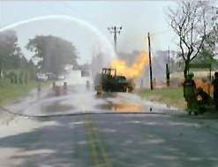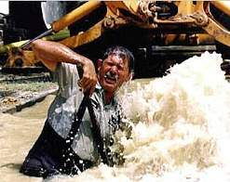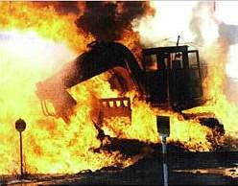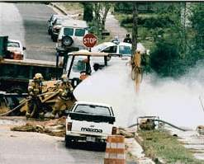

We’ve all seen movies where the hero has to cut the red wire or the blue wire to save the day. Well, out here at the excavation site, hitting any wire (or pipe) doesn't make you a hero, it usually just makes you the star of a very expensive, very loud, and very dangerous fireworks show.

Since we are operating in Virginia, we aren't just following general "good ideas", we are following specific state laws. In the city, the suburbs, or even out in the middle of nowhere, there is a high probability that a utility line is lurking right beneath your shovel. Striking one doesn't just ruin everyone's Netflix binge; it can be a fatal mistake.

To keep us all from becoming "internet famous" for blowing up a block, let’s go over how to dig without the drama.

1. CALL 811: It’s Not Just a Suggestion, It’s the Law! In Virginia, you never "just dig".

- The Call: We must contact Virginia’s One Call Notification Center (VA 811) before any excavation starts.
- The Wait: Per Virginia state law, you must provide a specific amount of lead time for utilities to be marked.
- The Timeline: Typically, this means allowing at least three working days, excluding weekends and holidays for the "Miss Utility" folks to come out and do their thing.
- The Proof: You must confirm that all utilities have been marked (look for the flags, paint, or stakes) before you even think about starting that engine.

2. Respecting the Virginia "Tolerance Zone"

Think of the "tolerance zone" as a utility line’s personal bubble.
- The Distance: While it varies by state, the Virginia standard expectation is 24 inches on either side of the marked line.
- Hands-On Only: Inside this zone, put the backhoe in park. You must locate the utilities using hand digging or other non-destructive methods approved by the Competent Person.

3. Support and Slow Down

- The Hanging Line: If you expose a utility, don't leave it hanging like a loose tooth. It needs to be supported so it doesn't collapse under its own weight.
- The Gentle Touch: When using hand tools near a line, "slow and easy" is the goal. Aggressive shoveling is a great way to earn an early (and unpaid) trip home.

4. Tattle on Yourself (and Others)

- Report All Nicks: If you hit a line, even if it just looks like a tiny scratch, report it to your Supervisor or the Competent Person immediately.
- The "Wait and See" Danger: Damage that goes unreported can corrode or rupture later, turning a small mistake into a major disaster. This also applies to any old damage you find from previous crews.

5. Backfilling: Don't Squash the Pipe

- The Soft Landing: Never dump a massive load of backfill directly onto an unsupported utility line.
- The Technique: Firmly pack soil under the utility first to create a stable bed, then carefully place and compact the soil over the top.

Bottom line: When in doubt, don't just "guess and dig." If you aren't sure about the procedure or a specific mark, ask your supervisor. It’s better to ask a "silly" question than to explain to the city why their power is out for the next six hours.

