TOOLBOXTALK SPOTTERS
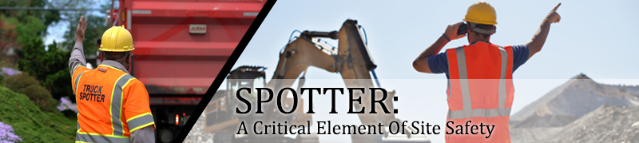

Alright folks let’s talk about backing up safely, and yes, we’re talking about using a spotter. Think of a spotter as the “eyes” for a driver who can’t see everything behind them. This applies to everything from dump trucks to delivery vehicles. If the driver can't see the whole backing path, the spotter’s got their back! But here’s the thing, the spotter’s job might seem easy, like just waving the driver back when it’s clear.
But, let me tell you, it’s more important than it looks. If done wrong, it could be the difference between a close call and a serious accident. There’s a lot going on in a busy construction zone, with people walking around, big machines moving, and sometimes you can’t even see what's behind you.
So, let’s break down what makes a spotter awesome at their job:

1. Know Your Job
The spotter is there to make sure the vehicle moves safely. The driver is trusting them to guide them in the right direction. No pressure, right?
2. Clear Signals Only
When you're signaling, keep it simple. No hand-waving mysteries, clear and consistent signals are key. If you don’t know the signal, don’t try to improvise.
3. Never Lose Sight of the Driver
Never, ever leave the driver’s view without stopping the vehicle. If you can’t be seen, nothing should move.
4. Behind the Vehicle? Not Unless It’s Stopped!
Don’t go behind a vehicle unless it’s stopped, and the operator is okay with it. Safety first, people!
5. Stay in Sight and Signal Properly
Always stand in a spot where the driver can see you, ideally on the driver’s side toward the back of the vehicle. This gives you a clear view of the path and helps avoid any “whoops, didn’t see you there!” moments.
6. Communication Is Key
If at any point you think the driver doesn’t know where you are, tell them to STOP. You’d rather be safe than sorry.
7. Watch Your Step
Don’t forget to watch where you're walking. Tripping is not only embarrassing, it can also be dangerous. Keep your eyes open for any hazards in your path.
8. Wear Safety Vest
Make sure you're wearing Safety Vest. It’ll help the driver spot you, and it might save you from becoming a blur in the background.

Teamwork Makes the Dream Work
Remember, spotters, operators, and drivers are all in this together. It’s not just about moving machines, it’s about moving them safely and keeping everyone on site out of harm’s way. So, work as a team, stay sharp, and let’s keep it accident-free out there!

