Toolbox Talks Identifying Hazards

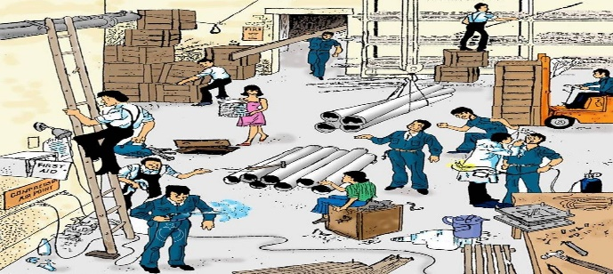

Workplace Hazards: Stay Alert, Stay Safe
Hazards are everywhere on a job site. They include sharp objects, dangerous materials like asbestos, power tools, electricity, poor weather, and even high-stress tasks like welding, cutting, or drilling. Spotting these risks early is essential to keep yourself and your team safe.
Types of Hazards
Workplace hazards usually fall into these categories:
- Biological: Germs, mold, or anything alive where it shouldn't be.
- Ergonomic: Awkward positions or repetitive motions that hurt over time.
- Physical: Noise, heavy objects, and machinery that can cause injuries.
- Safety Hazards: Trips, falls, and everyday job site dangers.

Every worksite is different, so always inspect the area before getting started.
How to Spot Hazards
Avoiding hazards is like avoiding spoilers for your favorite show—stay alert. Here’s a quick checklist:
- Keep walkways clear: A clean site is a safer site.
- Watch your crew: Know where your coworkers are to avoid accidents.
- Check everyone’s focus: Bad weather and stress can lead to poor decisions.
- Use gear correctly: Safety gear only works if you wear it right and keep it in good shape.
- Observe work areas: Look for anything that seems off or unsafe.
- Inspect ladders and platforms: Make sure they’re stable and used properly.
- Look up: Watch out for powerlines, trees, or falling objects.
- Check electrical equipment: Faulty wiring is not your friend.
- Report hazards: Tell your supervisor before a small issue becomes a big problem.

Final Thoughts
Staying safe isn't about being paranoid. It's about being smart. Identifying hazards, using your gear, and looking out for one another helps build a strong safety culture. In the end, we want to be remembered for building great things not for fixing accidents.
Stay safe out there. Safety first, selfies later!

