TOOLBOX TALK LOCKOUT-TAGOUT (LOTO)
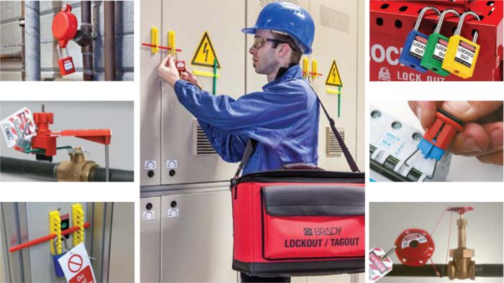
Today, we’re diving into something that’s not just important, it’s life-saving—Lockout-Tagout, or LOTO, for short.
Now, I know what you're thinking: "Lockout-Tagout? Is that just another fancy term for 'don’t get shocked or crushed'?" Well, sort of... but it’s also a legally-required, serious safety standard designed to keep us from getting zapped, squashed, or burnt while we're working on machines.
Why Lockout-Tagout Matters:
Each year, a LOT (and I mean a lot) of accidents happen because someone wasn’t paying attention to the hazardous energy lurking in the machines. We're talking about electrical, mechanical, thermal, and more—all the stuff that can hurt you if you don’t take the right precautions.
OSHA's got your back, though! They’ve got a handy rulebook called 29 CFR 1910.147 that lays out exactly how to control hazardous energy while doing maintenance or servicing equipment.
Types of Hazardous Energy (a.k.a. What Can Go Wrong):
- Electrical: ZAP! I don’t know about you, but I’m not a fan of feeling like a human lightning rod.
- Mechanical: Think spinning parts, belts, gears... basically anything that could leave you with a broken finger or worse.
- Gravitational: Heavy objects falling from above. It’s like gravity saying, "Hey, catch this!"
- Thermal: Burns, heat, steam—yeah, not the relaxing spa kind.
- Hydraulic & Pneumatic: High pressure fluids or air. Nothing says "fun" like explosive energy under pressure.
- Chemical: Who doesn’t love a good chemical burn? (Just kidding, don’t try it.)

When Do We Have to Use Lockout-Tagout Procedures?
- Servicing or Maintenance on Energized Equipment: If the machine’s running, your hands stay off. Period.
- Safety Measures Bypassed: If the safety guards are off, you must lock out that energy source before you get involved.
- Entering Danger Zones: If you're sticking your body where the action is—yeah, it’s time to lock it down.

When Can You Skip Lockout-Tagout? (Spoiler: Not Often)
- Routine Adjustments: Like, if you're doing the same thing every day and it’s part of normal operation—then sure, you don’t need to lock out... as long as you’re using other safety measures to protect yourself. But we’re talking routine, not “I just decided to stick my hand inside the machine because it’s Tuesday.”
The LOTO Lingo You Need to Know:
- Affected Employee: If you operate or work near equipment that’s getting locked out, you’re affected. And yes, that means you should know what’s happening around you.
- Authorized Employee: This is the trained individual who actually locks out the equipment to perform maintenance. It’s a big responsibility, but also pretty rewarding. (Like being the superhero of safety.)
- Supervisor: The boss, or the manager, of the Authorized Employee. Essentially, the safety czar in charge.
- Lockout: This is when you put a physical lock on the energy-isolating device. It says, “Don't touch this, it’s not happening until I say so.” It’s like putting the machine in timeout.
- Tagout: This is when you slap a tag on the energy isolator to let everyone know, “Hey, something’s going on here!” Best practice? Lock and tag. Always. Don’t be lazy.

The Energy You Don’t See (But Should Worry About):
Stored Energy
Things like springs, capacitors, hydraulic systems, and gas pressure don’t just disappear when you turn off a machine. They hang around waiting to catch you off guard. Make sure to dissipate this stored energy (bleed it off, reposition, block it—whatever it takes).
Can You Ever Work on Energized Equipment?
The short answer: Nope. If a machine is still "on," you can’t touch it. De-energize first, lock it out, then work. No exceptions.
The takeaway here is simple: Lock it out, tag it out, and you can keep it out of the ER. It might take a minute to do it right, but that’s way better than having to explain why you’ve got a finger missing. Safety’s no joke, but we can at least have a little fun while making sure we all go home in one piece.

