Toolbox Talk Hydration The Importance of Water

Why Water Matters on the Job: Water keeps your body working the way it should. On a construction site, you're moving, sweating, and often working under the sun — which means your body loses water fast. Without enough water, you can feel weak, dizzy, tired, or even get seriously sick from heat.
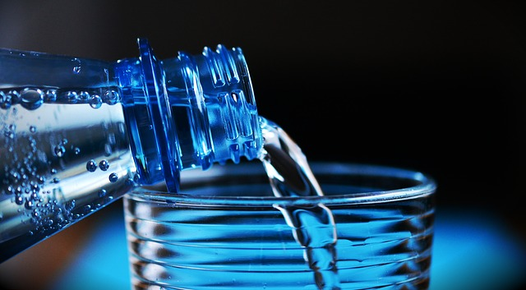

How Water Helps You Stay Safe and Strong

Over 60% of your body is water.

Water gives you energy. Not enough water is the top cause of feeling tired during the day.

It helps your brain work. Just a small drop in hydration can hurt your memory and focus.

Water cools your body. When it’s hot, you sweat. Sweating is your body’s cooling system — but it only works if you have enough water.

It keeps your joints moving smoothly. Like oil in a machine.

It flushes out waste. Water helps your body clean itself of toxins.

Hydration Tips
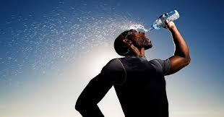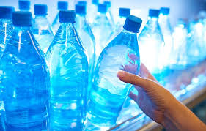
- Drink 3–4 bottles of water a day at minimum. That’s 50–64 ounces. You may need more if it’s hot or you're doing hard work.
- Don’t wait until you’re thirsty. If you’re already thirsty, you’re already getting dehydrated.
- Avoid sugary drinks, soda, coffee, and energy drinks. These can actually pull water out of your body.
- Check your urine.Light or pale yellow? You’re probably drinking enough.
- Dark yellow or going less often? Drink more water.

Signs of Dehydration
- Dry mouth
- Headache
- Dizziness
- Tiredness
- Muscle cramps
- Confusion (in serious cases)
Group Discussion:
Be honest — how many of you drink at least 3 to 4 bottles of water a day?
Let’s talk about what makes it hard — and how we can make it easier on the job.

