TOOLBOX TALK – CPR CAN SAVE A LIFE!
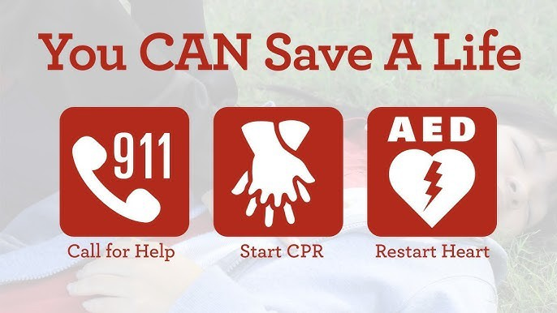

In the construction industry, safety is everything — and that includes being prepared for medical emergencies. Sudden cardiac arrest can strike anywhere, even on a job site. That’s why CPR and AED training isn’t just important — it’s essential. A trained crew can mean the difference between life and death. Let’s commit to being ready.

Cardiac arrest is an electrical malfunction in the heart that causes an irregular heartbeat (arrhythmia) and disrupts the flow of blood to the brain, lungs and other organs. Cardiac arrest is a leading cause of death.
Fact: Each year, more than 350,000 EMS-assessed out-of-hospital cardiac arrests occur in the United States. Of them, only about 40% of people who experience on out-of-hospital cardiac arrest receive the immediate help that they need before professional help arrives.
CPR combines chest compressions and breaths to provide additional oxygen to circulate throughout the body to keep vital organs alive. Calling 911 before beginning CPR is imperative as CPR only buys time until someone with more skills can provide help.
Research shows that 9 out of 10 people who suffer cardiac arrest outside of a hospital die – unless a bystander immediately performs CPR. Brain damage can start in 4 minutes and brain death can start in 8 – 10 minutes. An average EMS response time is 10 minutes or more.
So how can workers be prepared … and willing to help if a medical emergency occurs on the job? There are a number of organizations that offer CPR/AED training courses and can train workers onsite, including HCCA, increasing their skills and confidence. For instance, some people are concerned that they might break the victim’s ribs during CPR compressions. But think about it … a broken rib is better than the alternative (death) if not doing anything.
Some people may be unable or unwilling to provide rescue breaths to an unresponsive victim who’s not breathing. For them, a simpler version of CPR called “hands-only CPR” or “compression-only CPR” can be helpful. Hands-only consists of chest compressions delivered at a rate of 100-120 a minute – the same beat as the classic Bee Gees song “Stayin’ Alive”.
If you call 911, line up your hands on their chest and push hard and fast, you can help save a life. It’s not as hard or as complicated as a lot of people think.

