**Toolbox Talk Clothing and Safety**

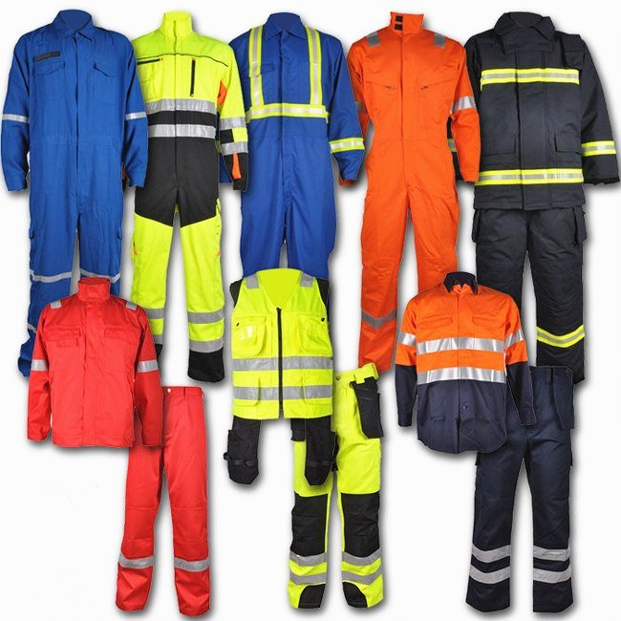

An important but often overlooked aspect of safety is what we decide to wear each day on the job. [Safety rules](https://www.osha.gov/SLTC/etools/electric_power/ppe_flameresistantclothing.html), weather, type of work, hazards of the work, and many other factors weigh in on what type of clothing is optimal for the tasks being completed that day. It is vital to consider the impact clothing can have on safety at work.

**Weather and Choice of Clothing**

Outside of safety rules and regulations, the weather conditions are the main deciding factor of what clothing someone is going to wear that day. The area where the jobsite is will decide many things about what a person should wear to work. Breathable thinner layers are more desirable in warmer temperatures. In [colder temperatures](https://www.safetytalkideas.com/safetytalks/winter-weather/),  thicker and warmer layers will need obviously to be worn to protect workers. In many climates, it may be necessary to wear warmer clothing in the morning and then wearing fewer layers in the afternoon.

It is important to plan what you are going to wear after considering the weather and how long you will be exposed to it depending on what work you are completing that day. Picking clothes that keep you comfortable as well as protects you from the elements is very important to allow you to fully focus on a work task. Not wearing the proper attire will take your focus off your work and put it on the fact that you are cold, hot, or wet since you were unprepared for the weather.

**Other Important Clothing Considerations**

* Make sure clothing fits properly. Loose clothing can interfere with being able to complete work safely. It can get caught in rotating equipment or on other objects.
* Do not wear clothing with big tears or holes. Tears or holes can also interfere with work. There have been incidents where a hole or tear in clothing has got caught on equipment controls. This can easily cause unintended movements, which lead to injuries and property damage.
* Bring extra clothing to work. Having extra clothes ensures you are able to change if you get a chemical on your clothing or they become wet. Whatever the problem may be, it is important to have the option to change. Being comfortable helps to allow you to focus on your work.
* Watch strings on hooded sweatshirts when working around rotating equipment or when working on equipment.  These parts can easily get caught up in rotating parts.
* Wear clothing that covers the skin when in areas where poison ivy or insects are a possibility. Covering your skin is the best way to protect yourself from these types of hazards.

**Summary**

Pay more attention to the clothing you choose to wear to work. Plan for what the weather will be or whatever the environment is if working indoors. Choose types of clothes that will protect you as well as fit comfortably. Proper clothing will allow you to focus on your work and work more efficiently.