***TOOLBOX TALK LADDER SAFETY TIPS***

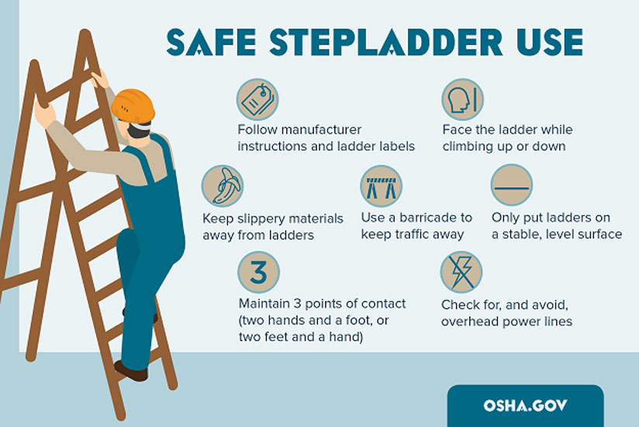

Do you know there's a killer on this job that you probably meet face-to-face every day? I'm talking about the common ordinary ladder. Ladders are involved in many accidents, some of which are fatal. Your life literally can depend on knowing how to inspect, use, and care for this tool. Let's spend a few minutes talking about ladders.

**INSPECTING LADDERS**  
  
Before using any ladder, inspect it. Look for the following faults:

1. Loose or missing rungs or cleats.   
2. Loose nails, bolts, or screws.  
3. Cracked, broken, split, dented, or badly worn rungs, cleats, or side rails.   
4. Wood splinters.   
5. Corrosion of metal ladders or metal parts.  
  
If you find a ladder in poor condition, don't use it. Report it. It should be tagged and properly repaired or immediately destroyed.  
  
**USING LADDERS**  
  
Choose the right type and size ladder. Except where stairways, ramps, or runways are provided, use a ladder to go from one level to another. Keep these tips in mind:   
  
1. Be sure straight ladders are long enough so that the side rails extend above the top support point by at least 3 feet (36”).

2. Don't set up ladders in areas such as doorways or walkways where they may be run into by others unless they are protected by barriers. Keep the area around the top and base of the ladder clear. Don't run hoses, extension cords, or ropes on a ladder and create an obstruction.

3. Don't try to increase the height of a ladder by standing it on boxes, barrels, or other materials. Don't try to splice two ladders together either!

4. Set the ladder on solid footing against a solid support. Don't try to use a step ladder as a straight ladder.

5. Place the base of straight ladders out away from the wall or edge of the upper level about one foot for every four feet of vertical height. Don't use ladders as a platform, runway, or scaffold.

6. Tie in, block, or otherwise secure the top of straight ladders to prevent them from being displaced.

7. To avoid slipping on a ladder, check your shoes for oil, grease, or mud and wipe it off before climbing.

8. Always face the ladder and hold on with both hands when climbing up or down, always maintain 3 points of contact. Don't try to carry tools or materials with you.

9. Don't lean out to the side when you're on a ladder. If something is out of reach, get down and move the ladder over.

10. Most ladders are designed to hold only one person at a time. Two may cause the ladder to fail or throw it off balance.   
  
**CARE OF LADDERS**  
  
Take good care of ladders and they'll take care of you. Store them in a well-ventilated areas, away from dampness.   
  
REMEMBER, these tips on ladders may save your life!

