**TOOLBOX TALK LOCKOUT-TAGOUT (LOTO)**

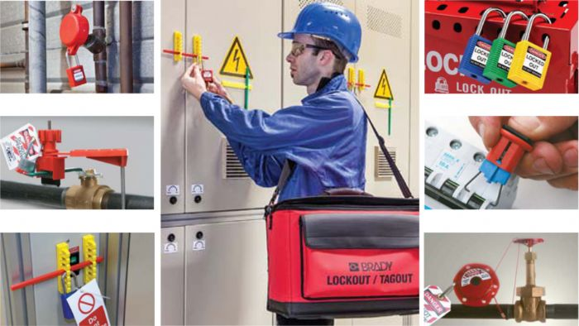

A lot of accidents happened due exposure to hazardous energy while servicing or performing maintenance on machinery or other equipment. OSHA 29 CFR 1910.147 details the requirements needed to control hazardous energy while servicing or performing maintenance.

**Types of Hazardous Energy:**

Electrical Mechanical Gravitational Thermal

Hydraulic Pneumatic Chemical

**When are Lockout-Tagout Procedures Required:**

Servicing/performing maintenance on energized equipment

Any form of work on equipment when safety guards or measures are bypassed

Any form of work which requires the individual to place any part of their body in the point of operation or designated danger zone

**When Are Lockout-Tagout Procedures *Not* Required:**

Routine, repetitive changes or adjustments that are integral to the use of the equipment; provided the work is performed using alternative measures that pro- vide effective protection

**Lockout-Tagout Definitions:**

**Affected Employee:** An employee whose job requires them to operate or use a piece of equipment that is affected by the Lockout-Tagout or is working in the area where the maintenance/service is being performed

**Authorized Employee:** A trained employee who locks out or tags out equipment to perform maintenance/service.

**Supervisor:** The manager/supervisor of the Authorized Employee

**Lockout:** The placement of a lockout device on an energy isolating device that ensures the equipment controlled by that energy isolating device cannot be operated until the lock is removed.

**Tagout:** placing a tag on an energy isolating device that notifies people of the work being done. A good safety practice is to always use a lock and tag every time the equipment needs to be deactivated and repaired.

**Stored or Residual Energy:**

**Examples of stored or residual energy:** Capacitors, springs, elevated com- ponents, rotating flywheels, hydraulic systems, and air, gas, steam water pressure etc.

**Methods of Dissipating or Restraining:** Grounding, repositioning, bleeding, blocking etc.

**When Can Employees work on Energized Equipment:**

***Never* – Employees are required to de-energize equipment in accordance with the Lockout-Tagout: Control of Hazardous Energy Standard**