**TOOLBOX TALK MIND ON SAFETY**

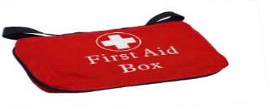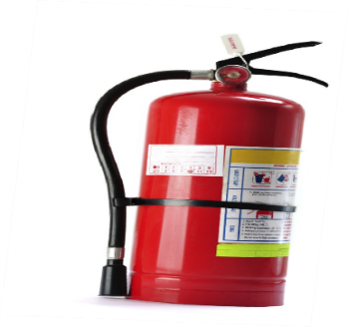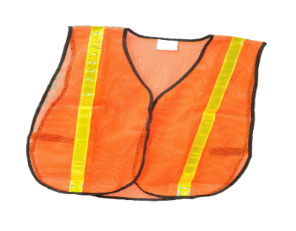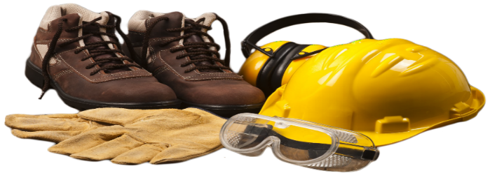

Anyone working in construction can understand what a challenge it is to get the job done when working against the elements. Heat, wind and extreme cold are only a few of the conditions we face every year. It may be easier said than done to keep your mind on the job when its 100 degrees Fahrenheit, but it’s very important to keep a clear mind and not forget the safe job procedures & personal protective equipment that should be used.

On a different note, we all have personal lives and personal issues to deal with that can easily affect our mindset. At times it can be difficult to not to think about these matters and let our minds wander when performing our daily jobs and responsibilities. If you are not focused on your task and how to do it safely you and your co-workers are at risk for an accident to occur. Thinking about the weekend, daydreaming, beeping cell phones or just not paying attention are other factors that could lead to an accident or fatality.

**KEEP YOUR MIND ON THE TASK**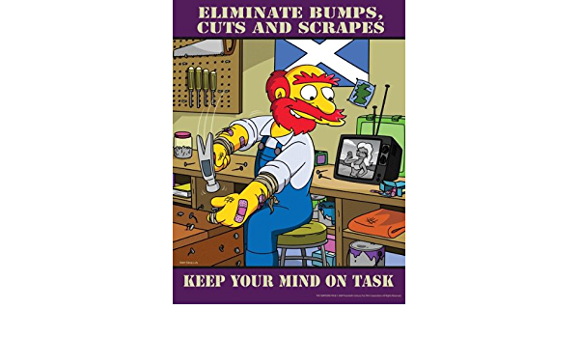

**REPORT IT, DON’T IGNORE IT**

Anything you encounter on the worksite that gives you a feeling of “That’s not safe at all” should be reported immediately. Don’t just put your head down and keep walking, hoping that someone else will report it. The same philosophy should also be used in respect to reporting near misses – a near miss could be the next accident.

**ALWAYS LOOK FOR HIDDEN HAZARDS**

While you are onsite, working conditions are always changing, therefore so will the hazards. These could be unexpected hazards that you may not typically encounter, so be aware of the changes around you. These can include workers who don’t see you enter their hazardous work area, low overhead pipes that may cause a head injury, unmarked floor openings and poor housekeeping that could result in slips, trips and falls. Keep your eyes open and your mind on safety.