**Toolbox Talks Personal Safety**

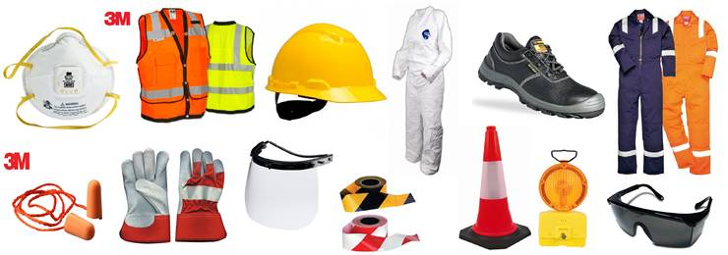

**Introduction:**

We encounter the subject of personal safety in almost every facet of our daily lives. We take many precautions to protect ourselves and our families from harm because many aspects of our daily lives present real potential dangers. The workplace is no exception. In fact, worksites are usually a lot more hazardous than any other situation we find ourselves in. It’s strange then, that personal safety at work is often taken for granted or neglected altogether.

**What Is Personal Safety?**

Personal safety refers to physical safety as well as emotional well–being. All workers have the right to the freedom from physical harm, the freedom from psychological or emotional harm including hostility, aggression or harassment, and the freedom from worry about physical safety and/or psychological harm.

When thinking about your personal safety on the job–site, consider the following Safe Work Practices:

✔ Remember that each worksite will present unique hazards to the individual worker. For safe work practices to be effective, they must be applied activity for every single work activity and always. When it comes to personal safety, simple common sense can go a long way.

✔ Know your rights and responsibilities.

✔ Always perform work in a way that will not cause injury to you, your co–workers, or any members of the general public.

✔ Refuse work you believe is unsafe. Never perform an activity or operate any equipment when you have reason to believe that doing so will create a danger to the health and safety of any person.

✔ Report all job–site incidents including accidents and injuries.

✔ Report all hazards immediately. This includes unsafe actions, conditions, equipment, and so on.

✔ Report any witnessed acts of violence or aggression towards yourself or any other workers.

✔ Never come to work impaired by drugs, alcohol or other substances.

✔ Wear the required PPE at all times.

✔ Always use appropriate fall protection when working at heights 10 ft or more.

✔ Never wear loose–fitting clothing when using power tools or machinery. Articles of clothing can get caught in the rotating parts and cause serious injury. Remove all jewelry.

**Final Thoughts:**

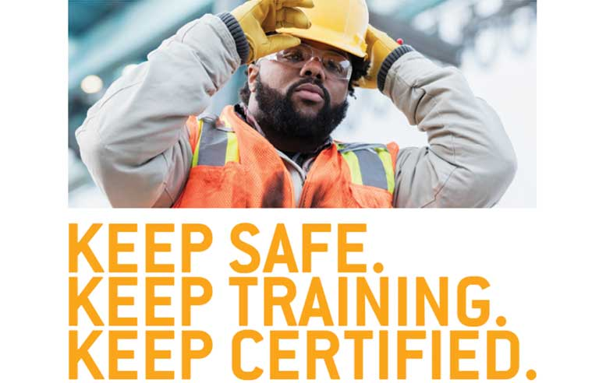

These minimum training and equipment requirements, if followed correctly, will greatly reduce the risk of serious injury on the job site. For more information regarding this subject, please reference the applicable sections of the Occupational Health & Safety Regulation.