**TOOLBOX TALK SAFE MATERIAL HANDLING**

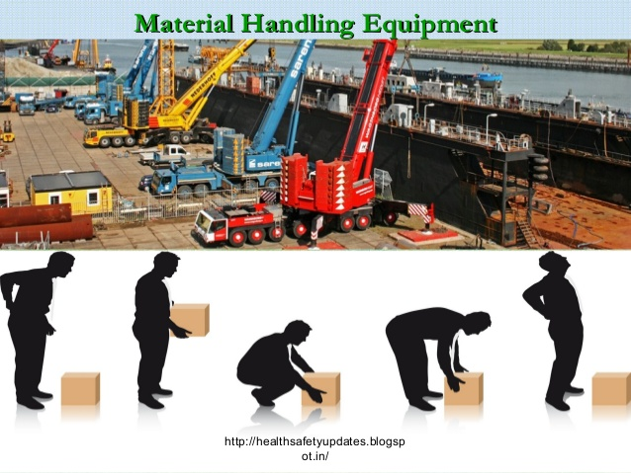

Workers suffer many painful injuries because they forget or are not properly trained in the basics of manual material handling. Here are a few pointers about lifting and safe handling of materials:

**Use required personal protective equipment:**

 

* Think of your toes in case something heavy drops. Always wear steel toed shoes when lifting or handling heavy objects.
* Think of your hands. Wear good strong gloves when you handle anything rough, sharp or splintery.

**Before you lift:**

* Test the load to determine its weight. Use tandem (multi-person) lifting or mechanical devices if the load is heavy or awkward.
* Be sure you've got a secure grip. Do not have anything in your hands when lifting other than the object you are lifting. Use lifting handles or handholds if provided. Strapping tape is not designed to serve as lifting handles.
* Be sure you have solid footing.
* Inspect the path you are going to follow while carrying the load. Make sure it is free of debris and obstacles.
* Check packaging to ensure it is secure and the load will not fall out while being handled.

**When you lift and carry:**

* Keep the load close to your body to minimize the strain.
* If the object is over your head, get a ladder or lift to get to it more easily.
* Do not reach to get an object off a pallet. Turn the pallet or walk around it to get closer to the item. If the item is light, slide it closer to you. Be careful if the item is sliding over shrink wrap or a wooden pallet as it may get caught.
* Crouch down with the load between your legs and get a good grip on the object.
* Lift smoothly and slowly with your legs. Keep your back vertical.
* Keep your body facing the load throughout the lift and while moving the load. Don't twist your body; pivot with your feet instead of your spine.
* Carry the load close to your body in the space between your shoulders and waist.
* Do not block your view with the load.
* Resist the temptation to carry that one extra box to avoid another trip.

**Use equipment (dollies, carts, two-wheelers, hoists or lifts) to move loads whenever possible. Push rather than pull if using a manual device to move the load. Play it safe and smart. Follow these pointers in all of your lifting and handling of materials.**