**Toolbox Talk: Sexism in the Workplace**

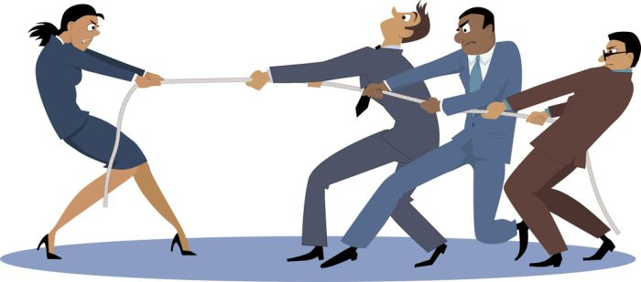

**WHAT COULD SEXISM IN A CONSTRUCTION WORKPLACE LOOK LIKE?**

When talking about the barriers to a truly inclusive workplace, companies need to go beyond the legal definition of sex discrimination or sexual harassment. Leading companies are also concerned about everyday sexism and the negative effects it has on overall company culture. While incidents of sexism can also be directed towards men, in an industry where women make up just ten percent of the overall workforce – and only three percent of the craft workforce – this toolbox series will focus on the everyday sexism directed against women. This toolbox talk takes a look at some hypothetical scenarios of sexism in the construction workplace and discuss the impact these incidents might have on women working in the construction industry.

**Scenario 1:**

A group of coworkers – all of whom are male – are working together in one area of the job site. One of the men tells the others that he is tired and needs to take a quick break to hydrate. One of his coworkers responds by telling him, “You can finish the job and then take a break. Are you on your period or something?” The rest of the men laugh and they all continue working, including the individual who wanted to take a break.

**Scenario 2:**

The project you are managing is behind schedule and you need a crew to work the weekend to catch up. You don’t ask your female employee to work overtime, knowing she has young children at home. When a leadership position in the company opens up, you recommend one of the male employees for the promotion, citing the overtime he put in to help the project get back on schedule as one of the reasons you’re recommending him for a promotion.

**Scenario 3:**

You are a new female apprentice working on a construction site and are consistently assigned tedious jobs – like sweeping the floor – that don’t help you build your skills in your chosen trade. When you talk to your supervisor about doing more tasks that will help you grow and gain expertise, you are told that they don’t want you “breaking a nail” on the job site and your request is ignored.

**Scenario 4:**

You are working on a job site with a female project manager. Her supervisor – who you admire and respect for his construction expertise and leadership – often puts his arm around her and tells how pretty she is. He jokes to her that she is a safety hazard for the men on the job site who are distracted by her looks. The female project manager reports these incidents to HR and the supervisor is terminated.

**Scenario 5:**

During client meetings, your client dismisses your female project engineer’s ideas and routinely interrupts and talks over her. However, when one of the men representing your company in the room repeats the project engineer’s ideas, the client readily accepts them.

**Discussion Questions:**

For each scenario discuss the following questions:

1. Put yourself in the shoes of each person in these scenarios. How would these experiences make you feel?

2. What affect do these types of incidents have on team dynamics and/or overall company culture?

3. How might these types of incidents affect safety on a job site?

4. How does this scenario impact women in the workplace?

Adapted by: WWW.BUILDCULTURE.ORG © 2021 The Associated General Contractors of America, Inc.