**Toolbox Talk – Housekeeping**

Lack of proper housekeeping on the job is one safety hazard common to all construction projects until after final cleanup. Good housekeeping is one item that can help improve not only the safety on the job, but also the morale and productivity of the job.

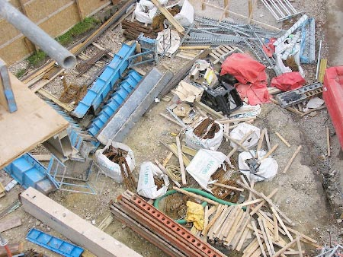

**Guide for Discussion**

The following “General Rules” should be covered in any discussion on housekeeping:

* Keep scrap lumber with protruding nails separate from other debris.
* Bend nails over or remove them from lumber.
* Keep all waste debris in neat piles and away from the immediate work area.
* Remove debris from the job on a regular basis.
* Keep aisles, stairways, and walkways clear.
* Store materials only in their designated areas.
* Place trash barrels where needed to eliminate food rubbish.
* Keep tools and equipment stored neatly.
* Keep extension cords from being across walkways. If necessary, run them overhead; same applies to air compressor hoses.
* Don’t let trash and debris build up. If it does, make an extra effort to get it cleaned up.

**Good Housekeeping Can:**

* Prevent minor injuries like cuts, punctures, slivers.
* Prevent major accidents like slips, trips, falls and fires.
* Increase job productivity by speeding up the movement of workers and materials on the job.
* Keep compliance inspectors from visiting the job.

**Remember: Good housekeeping aids everyone and makes it easier for everyone to do their work safely and with more pride.**