**Toolbox Talk Mind on Task**

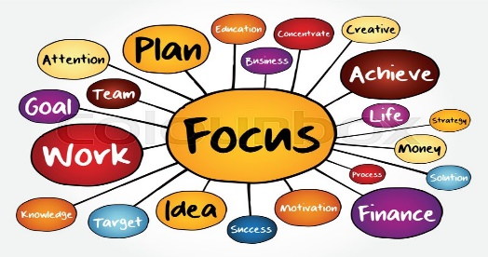

**THE DANGERS**

Some of the contributing factors that cause our minds to wander off task are rushing, fatigue, frustration, complacency, anger, etc. These emotions and states can contribute to the making of critical mistakes. All your good habits and training can go out the window and risky behavior takes over.

* **Not Watching What We’re Doing**. Most of us have had our fingers pinched in a car door at one time or another. Now if we’d had our eyes on what we were doing, our reactions would have taken over and we would have jerked our hand out of the way. Not watching what we were doing took away our ability to react.
* **Not Concentrating on What We’re Doing**. Not all hazards are visible. Some hazards must be thought about and prepared for. We need to know they are lurking even if we can’t immediately detect them with our eyes. Examples: A hot stove, a film of oil on the roadway and electricity. We need to concentrate on the task we’re performing so that we can recognize and avoid the hazards.
* **Being in or Moving into the Line of Fire** - Failing to recognize that we are in the line of fire is another cause of accidents. It’s often the result of not keeping our eyes and mind on the task at hand**.**
* **Loss of Balance, Traction or Grip**. This type of error is also apt to occur when our eyes or minds are not on task.
* **Multi-tasking** – We are conditioned to believe that multi-tasking is efficient, but successful multi-taskers are rare. Multi-tasking dilutes your focus. Every time your mind switches gears, you lose a little time. Most of us can't talk on the phone, read email, and give instructions, at the same time — and do so efficiently.

**HOW TO GET BACK ON TRACK**

The best way to protect yourself is to recognize when you’re feeling rushed, tired, or frustrated, learn the signs and use it as a warning to prevent injuries. The next time you find yourself in a state of mind that contributes to risky behavior, take a deep breath, and say to yourself, “Hey, if I keep this up, I’m going to hurt myself.” Take the time to get your mind back on the task and keep yourself safe.