**Toolbox Talks Identifying Hazards**

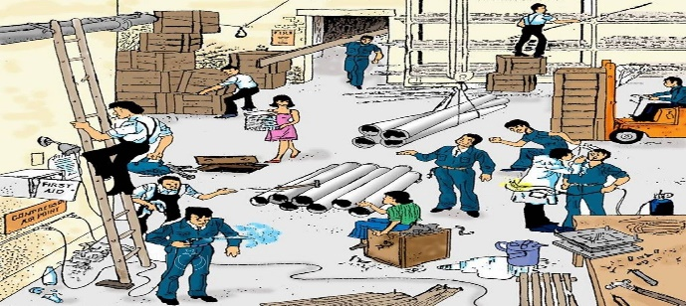

Hazards in the workplace are numerous. They can include objects, substances, material like

asbestos, sources of energy, workplace conditions, and even work processes like welding, drilling or cutting. Identifying hazards in the workplace and planning accordingly is a necessary practice that will help you and your fellow workers.

**Types of Hazards**

Hazards are generally classified into one of several different categories. These include biological, ergonomic, physical, and safety hazards. Note that these are only some examples. Each worksite is unique and must be inspected thoroughly before any work begins.

**Identify Job Site Hazards**

There are hazards that become overlooked, but most workplace hazards can be recognized if

time is taken to identify them.

1. Keep narrow pathways and high traffic areas free of debris by following a diligent housekeeping program.

2. Be aware of all workers and their locations to prevent any danger to yourself or your fellow workers.

3. Be aware of all workers’ state of mind and consciousness when working a high stress job or in bad weather.

4. Be sure that safety equipment is used properly and is kept in good condition and well maintained.

5. Observe workstations to spot any unsafe procedure or process.

6. Ensure that ladders or work platforms are in good working condition and are being used

correctly for the application.

7. Keep mental notes of any overhead hazards including powerlines, trees, and more.

8. Be sure that electrical equipment is in good working order and free of any faulty wiring.

9. Be sure that the supervisor is made aware of all hazards on the job site.

**Final Thoughts**

It is important to have several different methods of identifying health and safety hazards to ensure a safe work environment for employees. Taking the necessary steps will make a difference and help to create a health and safety culture that will be beneficial for everyone.