**TOOLBOX TALK WORK ZONE SAFETY**

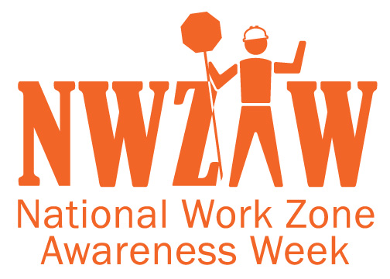

If you’re working on the road, carrying out essential works, there are things you can do to reduce the risk of accidents from occurring. This is important because working on the road can be very dangerous due to all of the vehicles and heavy equipment that are in your work zone.

In this road work safety toolbox talk, we will go over the main road works hazards and how you can minimize the risks.

**Why Run a Road Work Safety Toolbox Talk?**

* Helps you be aware of hazards when working on the road
* Helps you to be able to identify risks and then minimize those risks
* Helps you to know the correct safety procedures while working on road projects
* Ensures we all know our responsibilities to maintain a safe workplace (including management)
* Safety improves productivity

**Common Road Work Hazards**

When working on or near the roads, there are a number of hazards that you need to be aware of, including:

* Moving and idle construction vehicles and equipment
* Moving vehicles driven by the public
* Heavy vehicles such as trucks
* Traffic management (especially if not adhered to)
* Noise from equipment and vehicles
* Limited visibility—caused by things like dust from vehicles and equipment
* Limited lighting (for example, working at night)
* Bad weather such as rain, sun, and high winds
* Natural hazards such as slips, trees, and vegetation

In some instances, even livestock and wild animals!

**Road Works Best Practices**

**Have a Plan.** The main way to avoid hazards on a road worksite is to have a detailed plan for the job. Make sure you identify all specific risks and have a plan in place to minimize them. Make sure every team member knows the plan before work commences.

**Safety First.** Always ensure the correct signage, traffic control systems, road markings, etc. are in place. Before heading out to the worksite, make sure you have all of the equipment with you.

**Wear Correct PPE.** When working in traffic, wear the correct PPE such as a reflective high-visibility vest, hard hat, eye protection (when required), the appropriate clothing, and protective footwear.

**Get in, Get it Done, Get Out.** By this, we mean always minimize the amount of time staff needs to be exposed to traffic. The best way to achieve this is to be prepared.

**Ensure Correct Training.** All staff on a road worksite need to be properly trained in all aspects of safety. For example, the traffic control team needs to be fully trained. Only the required staff should be onsite too.

**Remove Hazards.** Always ensure that all waste is removed from the worksite ASAP and that equipment that is not required is removed when no longer needed.

**Have Emergency Plans.** Accidents do happen. For this reason, you must have emergency plans in place in the event of an accident. All staff must be made aware of the emergency plans before work commences. Depending on the specifics of the job, you may require backup plans in place too.

**Key Takeaways**

* Be aware of the hazards around you when working on the road such as equipment, vehicles, and machinery.
* Always make sure there is a detailed plan in place, and you are aware of it, and then stick to it.
* Remember, safety first!
* Always make sure you take and then wear the correct PPE.
* Only spend as much time as you need to when working on the road. This helps to minimize the risk of accidents happening.
* Everybody on the worksite should have the proper training.
* Remove any hazards when you see them.
* Make sure there are emergency plans in place in the event of something going wrong.  
    
  