**TOOLBOX TALK – Excavation and Trenching**



The OSHA Standard for Excavation and Trenching applies to any man-made cut, cavity, trench, or depression in the earth’s surface formed by earth removal. Excavations are defined to include trenches, which are defined as narrow underground excavation deeper than it is wide, and is no wider than 15’. There are many hazards but most can be placed into four categories:

• Underground utilities

• Confined space hazards

• Cave-ins

• Overhead power lines

Cave-‐ins are the most common hazard associated with excavations. Cave-‐ins can be the result of unsafe work habits, changes in weather that affect soil stability, and/or vibrations caused by construction activity. Underground utilities are of major concern if there is any possibility of natural gas or electrical lines. You must always be alert for changing conditions.

**Pre-Excavation**

• Call the national “Call Before You Dig” number 811 or locally designated number to verify that utilities are marked and the depth is verified before starting any digging activities. (All personnel must know this has been completed for their safety.)

• Wear appropriate personal protective equipment (PPE) as required by the task being performed and as required per OSHA regulations.

**Occupied Excavation**

The competent person needs to conduct a visual inspection once the excavation has been opened. The definition of a Competent Person is:

*One who is capable of identifying existing and predictable hazards in the surroundings or working conditions which are unsanitary, hazardous, or dangerous to employees, and who has authorization to take prompt corrective measures to eliminate them.*

**THINGS YOU SHOULD DO IN THE WORKPLACE:**

* Call the national “Call Before You Dig” number 811 or other locally designated number to locate underground utilities prior to starting work
* Keep material, equipment and spoils at least 2 feet back from the edge of an excavation.
* Provide ladders, stairways, ramps or other means of egress in all excavations that are 4 feet deep or greater.
* Position a means of egress within 25 lateral feet from workers.
* Ensure the excavation is inspected by a competent person prior to working.

**THINGS YOU SHOULD NOT DO IN THE WORKPLACE:**

* Do Not enter an excavation after a rain event until a competent person has properly inspected it and water has been removed.
* Do Not work on top of exposed utility pipes until they have been properly backfilled.
* Never enter an excavation until a competent person has inspected it.

**Ensure that the following Best Practices are followed if the excavation is to be occupied:**

* No employee shall enter any excavation until necessary protective systems are in place and the competent person has determined that the excavation is safe to enter.
* Maintain a 2 foot lateral open area between the edge of the excavation and any material, equipment, and spoil.
* Assure that proper sloping, benching, or shoring techniques are utilized in excavations of 5 feet or greater in depth. Be aware of different soil classification and use the correct sloping for each classification.
* There are 4 types:

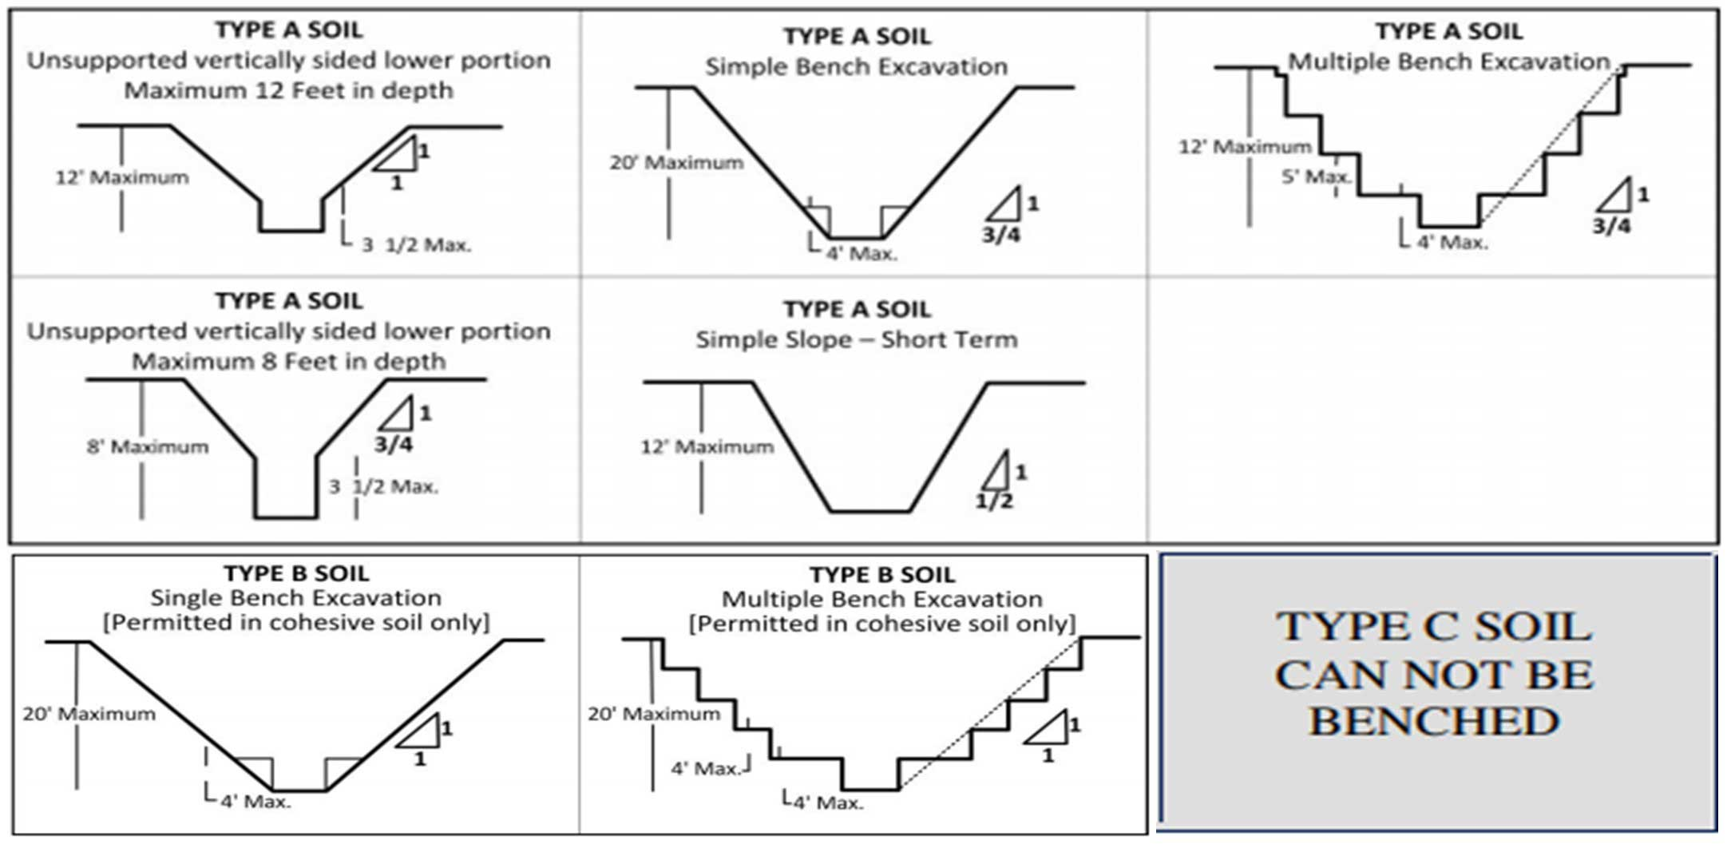

1 Solid Rock Vertical (90 Deg.)

2 Type A 3/4 : 1 (53 Deg.)

3 Type B 1: 1 (45 Deg.)

4 Type C 1 ½: 1 (34 Deg.)

* Check for and remove any accumulation of water in the excavation.
* If the excavation is 4 feet or greater in depth, ensure a fixed means of proper egress within a maximum lateral travel distance of 25 feet.
* Ensure that the competent person inspects and documents the excavation checklist at the beginning of each day, each shift change, and after every change of weather (i.e. rain storm)
* Protective systems for excavations of 20 feet or greater in depth must be designed by a registered professional engineer.
* Ensure that the public will be protected from all open excavations.

**Backfilling**

* Ensure all personnel, tools, and foreign materials are clear prior to backfilling.
* Comply with company specifications for backfilling.
* Ensure the protection and support of existing utilities and structures.