 Heavy Construction Contractors Association 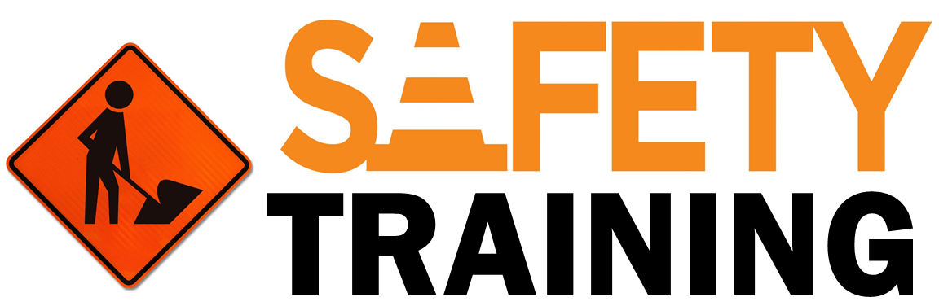

9251 Industrial Court-Suite 201, Manassas, Virginia 20109

(703) 392-7410 phone / (703) 392-7249 fax

**Toolbox Talk Hand and Power Tools**

Often times we overlook the hazards associated with the common tools that are used on a daily basis. With this talk we hope to bring some awareness to the potential hazards of these tools and how to minimize these hazards.

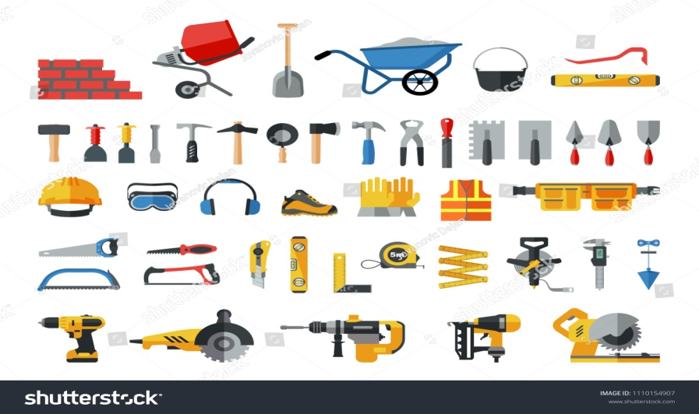

**Training:**

* Each employee using hand and portable power tools must receive initial training and an annual refresher.

**Pre Inspection Use (Done before every use):**

* Damaged or cracked housing, power source, or bits/accessories
* Dull blades are often more dangerous than sharp blades
* Missing guards or protective devices
* Leaking gasoline, oil or other fluids
* Tool appears to be in poor condition
* Does the tool have a 3 wire cord, if not is it double insulated?
* Ensure area is free of any potential trip hazards
* Do not underestimate the importance of a clean work area

**Proper Use:**

* Ensure you are wearing the correct PPE
* You should always wear eye protection
* Use the proper tool for the job
* Follow the manufacturer’s instructions
* If unsure about use, ask a supervisor or coworker for clarification
* Insure tools are not pointed at or operated in close proximity to other individuals
* Use spark resistant tools when working near a fuel source
* Do not use excessive force to cut/drill through hard materials
* Gasoline/Mixed Fuel Powered Tools must be off and cool when re-fueled, use only in well ventilated areas.

**Storage:**

* Drain fluids (gasoline) if equipment will be in storage for an extended period of time
* De-energize tool prior to storage (includes removing air pressure, hydraulic pressure and removing loads).
* Store electric tools in dry areas
* Store flammables in accordance with applicable OSHA regulations

**Group Discussions:**

* Has anyone in the group been injured by a power tool or had a close call? How could this injury have been prevented.
* What tools present the greatest hazard in your work environment? How can you minimize these risks?
* Are there any tools that need to be repaired or discarded? If so take time to do this immediately after the talk.