Toolbox Talk Pre-Shift Inspections

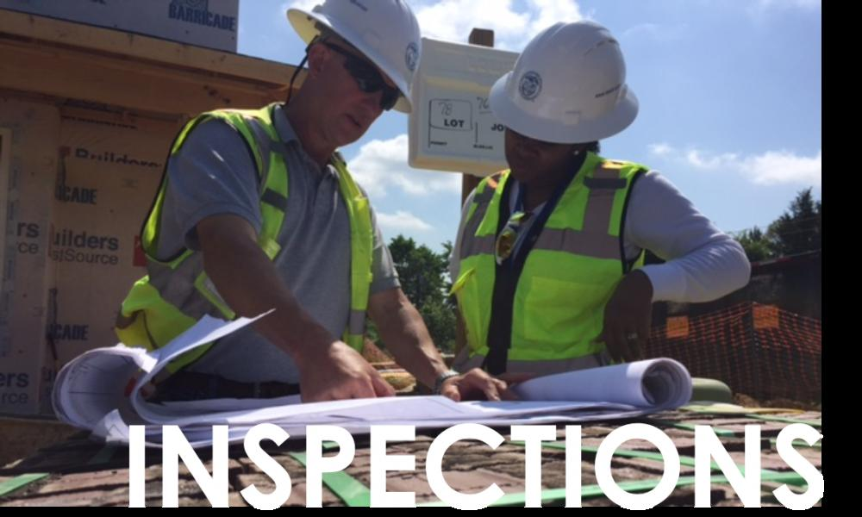

Have you looked around your workplace recently? Most likely you will find a few hazards that you need to correct to prevent you or one of your coworkers from getting hurt.

To avoid workplace injuries, here are some safety tips to consider:

Avoid Slips and Falls

* Make sure cords are not underfoot to prevent employees from getting their feet tangled.
* Use a stepladder when retrieving something from a high shelf. Don't stand on desks or chairs.
* Report all loose carpeting and broken tiles so that repairs can be planned.
* Keep all hallways free of clutter.
* Clean up all spills immediately.
* Maintain adequate lighting in work areas.
* Make sure all ramps, gangplanks and loading docks are in good repair.
* Carry objects that could obstruct your view by gripping from the corners.

Electrical Safety

* Visually inspect all electrical equipment before use. Take any defective equipment out of service.
* Use Ground Fault Circuit Interrupters (GHCI) to prevent ground faults.
* If you use an extension cord, make sure that it is the proper type for the equipment or appliance so it is not overloaded.
* Avoid overloading an outlet.
* Make sure that tools are turned off before plugging them in and when unplugging.
* Ground all power supply systems, electrical circuits, and electrical equipment.
* Frequently inspect electrical systems to insure that the path to ground is continuous.
* Do not remove ground prongs from cord- and plug-connected equipment or extension cords.
* Use double-insulated tools.
* Ground all exposed metal parts of equipment.
* Do not use “cheater plug” adapters as this removes the path to ground.
* Avoid standing in wet areas when using portable electrical power tools.

Personal Protective Equipment

* Inspect all PPE before use and replace as needed.
  + Safety glasses should be checked for pitted or scratched lenses. Deeply scratched or excessively pitted lenses are apt to break, and should be replaced.
  + Hard hats with any perforation, cracking, or deformity of the brim or shell, or an indication of exposure to heat, chemicals or UV light should be removed from service and replaced.
  + Suspension systems are offered as replacement parts and should be replaced when damaged or when excessive wear is noticed. It is not necessary to replace the entire hard hat when deterioration or tears of the suspension systems are noticed.
  + Always replace a hard hat if it sustains an impact, even if damage is not noticeable.
* Hard hats should be worn when overhead hazards exist, and when required by policy.
* Wear proper footwear for the work you perform.
* Wear safety glasses when eye hazards exist. A wide selection of safety glasses is available, including those that can be worn over existing prescription glasses.
* Wear earplugs or earmuffs when exposed to high noise levels.

Ergonomic Hazard Control

* Eliminate excessive leaning or reaching when possible. If possible, reposition the workbench to allow for neutral postures. Use proper EPP techniques and work in the green zone as much as possible.
* Get Help Not Hurt! If a load is too heavy for you to lift by yourself, get someone to help you or use a lift assist device.

Work Environment

* Before the work day begins, or before starting a task, verify walkways and exits are not obstructed.
* Make sure that the lighting in the work environment is adequate. Eye strain and improper lighting can affect other parts of the body, including causing shoulder stiffness and back pain.

Other Safety Tips

* Inspect all tools and equipment prior to use. Repair or replace damaged equipment.
* Do not attempt to start equipment/machines that are locked out or tagged out.
* Do not attempt to remove or tamper with locks or tags for any reason.
* Only use tools and machines that you are trained and authorized to use.
* Never remove or tamper with machine guards.
* Verify machine guarding is in place and working properly. If it is missing or not working properly, take the equipment out of service until it can be repaired.
* Verify emergency stops are in place and appear to be functional (for stationary equipment).
* Verify brakes are functional (including parking brake) for mobile equipment.

