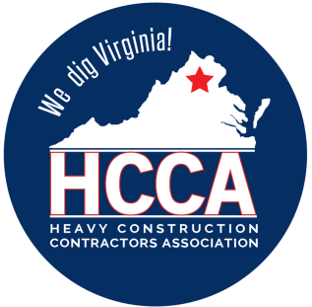 Heavy Construction Contractors Association 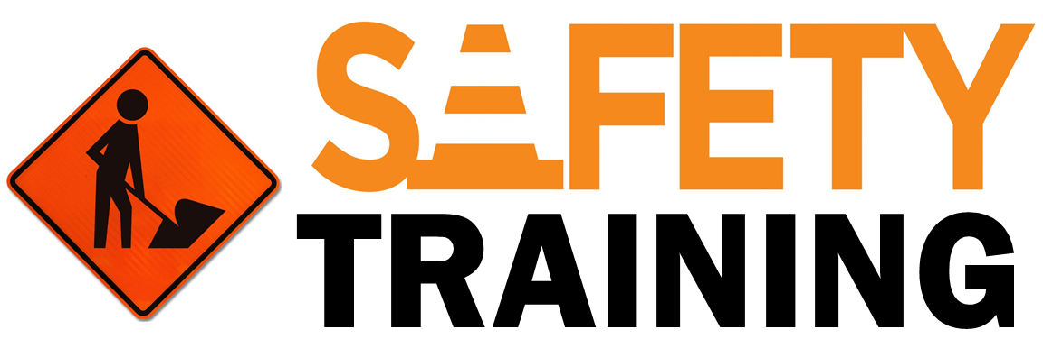

9251 Industrial Court-Suite 201, Manassas, Virginia 20109

(703) 392-7410 phone / (703) 392-7249 fax

***Toolbox Talk -******SPRAINS AND STRAINS IN THE CONSTRUCTION INDUSTRY***

*Note to Supervisor: This 5-Minute Toolbox Talk is designed not only to communicate important safety information to your employees, but also to be given to them by you, which will hopefully reinforce the message and let them know your expectations for safety. You can use the text below as a script to be rendered verbatim or just as talking points to be stated in your own words.*

***The days of macho behavior and contests to see who can do the most work or lift the heaviest load are hopefully gone! Companies that allow behavior like this to exist find themselves out of business because accidents and injuries-and worker's compensation insurance costs-skyrocket.***

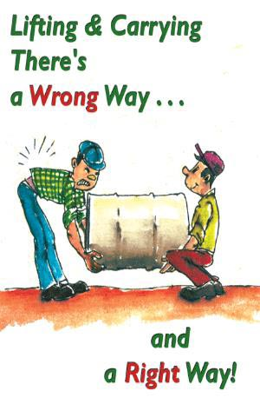  
  
***The answer is in planning:*** In the dynamic construction industry, controlling exposures to sprains and strains is difficult at best. With this in mind, anyone who spends a good part of their work day moving materials should learn to work smarter, rather than harder!

***Manual material handling is common to many industries, especially construction***. Many tasks that require handling sheet goods, such as plywood siding or sheet rock, require two people for installation. Experience working together as a team is the best way to assure you know what your partner is doing. When starting with a new partner, take time to discuss how you intend to lift, carry and secure your work. A single wrong move with a heavy sheet can transfer the full load to one of the workers, force an awkward position, and cause a sprain or strain.

***When working from scaffolding, take time to plan your moves***. How will you get the material in place? Will you have to move it around the scaffolding manually? Do you need mechanical help such as a fork lift or a boom truck? Can you place material in several locations to minimize the need to lift and carry? All of these situations should be considered before starting a task.  
  
***When loading or unloading materials or tools, avoid bending, twisting or carrying long distances***. If it's possible, avoid placing materials at heights below knee level or above shoulder level. Never twist with a load!! This is one of the worst things that you can do to your back. If you combine bending and twisting, you are certain to injure yourself. Always allow space for at least two steps between a truck being off loaded and the final stacking site, which helps avoid twisting. Place a couple of pallets under a pallet you are stacking, which avoids bending below knee height.

***Shoveling:*** When using a shovel, alternate having your left hand and right hand forward. It may feel awkward at first, but allows muscles on both sides of your body to share the work. Keep in mind that muscles and posture control the shape of your spine. The shape of your spine controls wear and tear on your spinal disks, muscles and ligaments.  
  
***Repetitive motion:*** Tasks that require repetitive hand or wrist motion should be examined closely. Steady use of a screw driver means constant twisting of the wrist. Battery operated screw guns are a good answer for this. Driving nails all day can cause pain in both your elbow and wrist. Wooden handles tend to transmit less vibration than steel and fiberglass hammer handles. Consider wearing a tennis elbow support, to limit the effect of vibration on tendons that attach to the elbow. When using vibrating tools, special gloves that "dampen" vibration can also be worn.  
  
***Problem-solve and plan with others:*** The first step to avoiding discomfort, pain or injury is to discuss awkward work tasks with your supervisor. Also, share your concerns and possible remedies with co-workers at safety meetings. Remember, the best way to earn a living is to stay healthy. Your employer-and most of all, your family-are depending on ***YOU***!