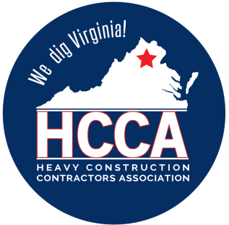 Heavy Construction Contractors Association 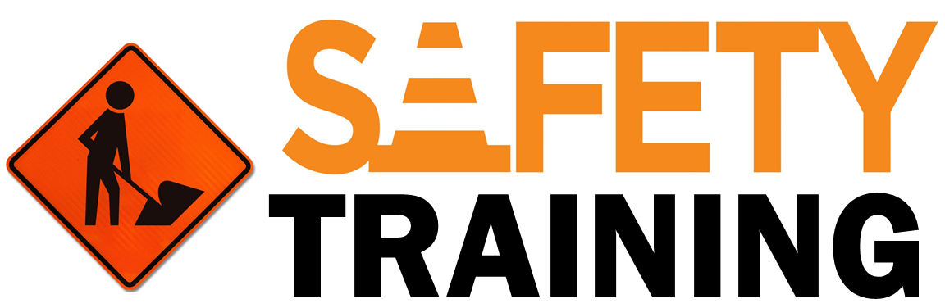

9251 Industrial Court-Suite 201, Manassas, Virginia 20109

(703) 392-7410 phone / (703) 392-7249 fax

**Toolbox Talk Spring Safety Tips for the Construction Site**

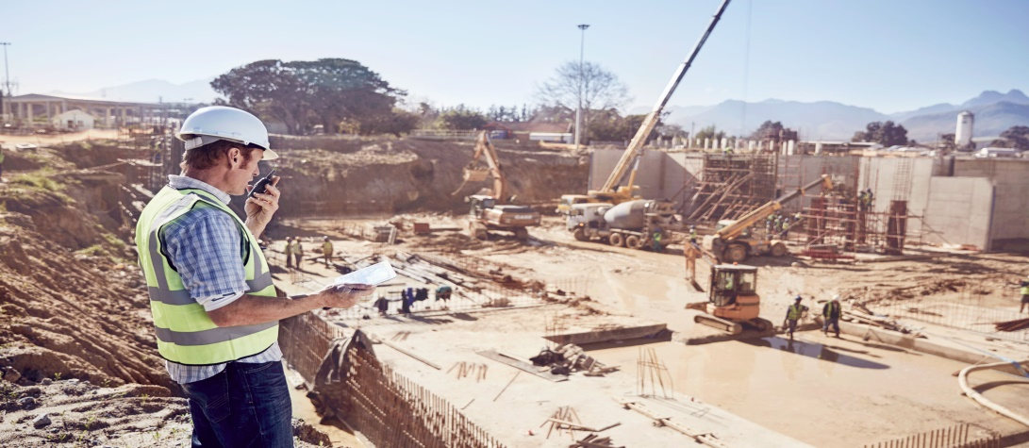

Along with warmer weather and yard work, the spring season brings frequent rainfall and the possibility of pop-up thunderstorms and lightning. On busy construction sites, the unique dangers that spring weather poses to the safety of workers and site visitors can not be underestimated. From an increased likelihood of slips and falls to the risks posed by bad weather, here are 4 Spring Safety Tips for the Construction Site.

***Seeing Clearly***

On a construction site, goggles or eye-shields are an important part of ensuring the safety of workers. However, when your goggles become obscured by rain or excess moisture, it can result in a serious accident.

Construction site safety toolkits should include clean, dry cloths so that workers can wipe off their safety goggles and anti-fogging sprays to use before work begins at the job site. Since overcast days are common in the spring, management should also consider installing outdoor lighting to illuminate workspaces on days that are particularly dark or cloudy.

***Wear the Right Gear***

Spring rains often lead to an increase in fog, especially in the mornings, and can make visibility difficult. Personal protective equipment (PPE) that takes these conditions into account should be provided to all employees, especially during low-visibility situations.

When working on roadways or near traffic, construction workers should be equipped with bright, reflective outerwear at all times. The reflective material allows motorists to see and better identify workers when they’re driving through a construction zone during rainy or foggy conditions. Additionally, waterproof gear and protective coats and hoods can help keep your crew working through showers without discomfort.

***Get a Grip***

On a construction site where dirt and grime are just part of the job, muddy boots and gloves can be a harbinger of serious danger.

Muddy boots or gloves prevent your employees from getting a good grip on equipment such as ladders or machinery, and can result in a slip or fall. In an active construction zone, these types of accidents often result in far greater injury than those that occur in other work environments. Be sure to keep extra pairs of work gloves available for employees who need them. Provide an area where employees can clean muddy or wet work boots throughout the day.

**Keep an Eye on the Sky**

The spring season is notorious for pop-up showers, unexpected strong winds, and serious storms. Providing employees with the tools they need to stay safe in these conditions is critical to maintaining a healthy work environment.

When working at heights, safeguard your employees with fall protection PPE. Be sure that all workers understand how to fit a body harness, that the harnesses are being checked by a safety partner, and that you identify safe anchor points for personal fall arrest systems.

It’s also important that your team is prepared for when spring thunderstorms and showers strike, often unexpectedly. Construction workers operating outside, on or near tall, conductive materials like cranes or steel building frames, are particularly susceptible to these foul weather events. Review your protocol for lightning with your employees to ensure that they understand what to do in the event that bad weather suddenly hits. Per OSHA requirements, your team should immediately move to a safe place if they hear thunder, even if the thunder is distant