 Heavy Construction Contractors Association 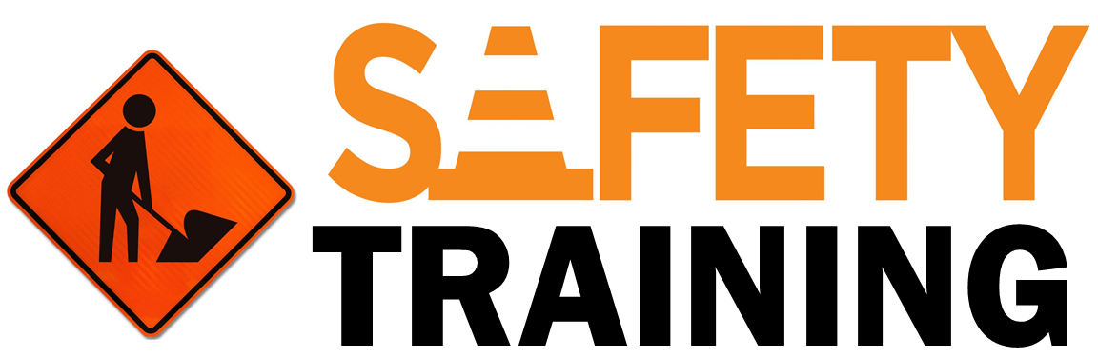

9251 Industrial Court-Suite 201, Manassas, Virginia 20109

(703) 392-7410 phone / (703) 392-7249 fax

***Toolbox Talk - Whose Responsibility Is It?***

After an accident has occurred, it is not unusual for those who were around the injured worker to feel guilty. This guilt is part of each person’s inner awareness that there was possibly something they could or should have done to prevent the accident. Sometimes the accident is the result of someone else’s mistakes. But who causes the accident is not as important as who is responsible for the accident, and what steps will be taken to correct future similar accidents from happening. The following is a partial list of responsibilities for safety on the job.

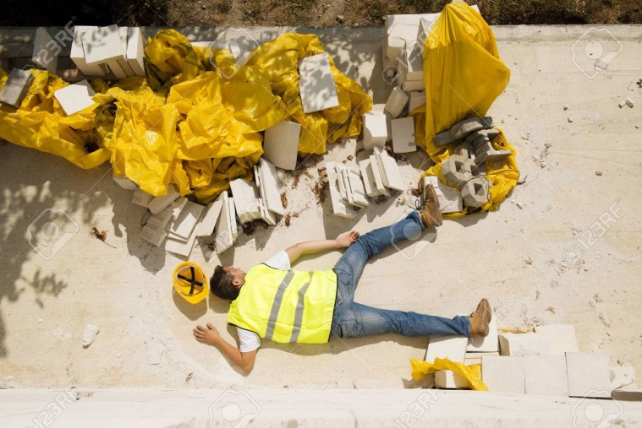

***Guide for Discussion***

* Who’s Responsible? (Discussion Points)
* Senior company management?
* Crew supervisor?
* Each person on the job?
* Trained safety professionals?
* Company safety committee?

***Some Responsibility Rules for Everyone***

* If it’s unsafe for you then it’s unsafe for the next person and the hazard should be corrected.
* Safety doesn’t belong to any one construction craft; rather it is part of every construction craft to be responsible.
* If safety doesn’t begin with you, it won’t begin at all.

***An Individual’s Responsibility***

* To yourself
* To your family
* To your co-workers
* To your company

***Remember:*** Workers’ compensation checks won’t pay all the bills nor will they replace the self-esteem one has from being a good provider to their families. Without complete cooperation from everyone on the worksite, it just will not be as safe as it should be.