Top Four
Construction Hazards
The top four causes of construction fatalities are: Falls, Struck-By, Caught-In/Between and Electrocutions.
Prevent Falls  - Wear and use personal fall arrest equipment.  - Install and maintain perimeter protection.  - Cover and secure floor openings and label floor opening covers.  - Use ladders and scaffolds safely. | 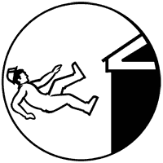

Prevent Struck-By  - Never position yourself between moving and fixed objects.  - Wear high-visibility clothes near equipment/vehicles. | 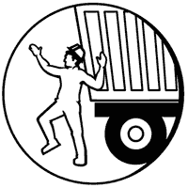

Prevent Caught-In/Between  - Never enter an unprotected trench or excavation 5 feet or deeper without an adequate protective system in place; some trenches under 5 feet deep may also need such a system.  - Make sure the trench or excavation is protected either by sloping, shoring, benching or trench shield systems. | 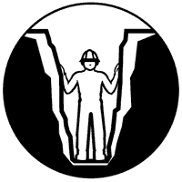

Prevent Electrocutions  - Locate and identify utilities before starting work.  - Look for overhead power lines when operating any equipment.  - Maintain a safe distance away from power lines; learn the safe distance requirements.  - Do not operate portable electric tools unless they are grounded or double insulated.  - Use ground-fault circuit interrupters for protection.  - Be alert to electrical hazards when working with ladders, scaffolds or other platforms. | 