 Heavy Construction Contractors Association 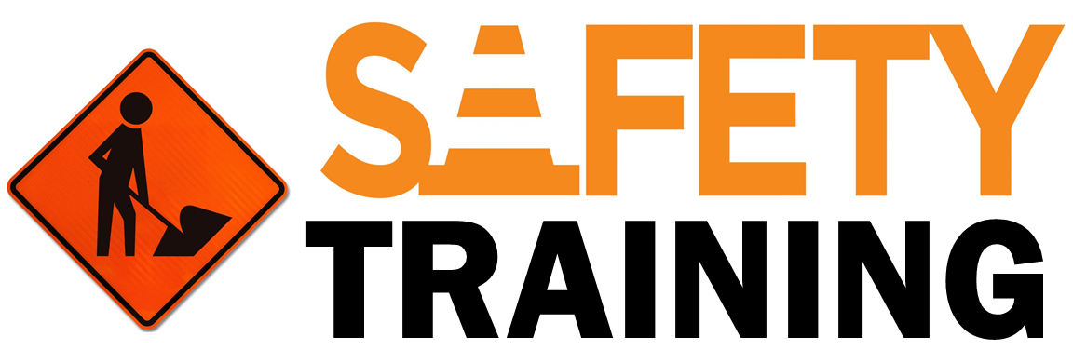

9251 Industrial Court-Suite 201, Manassas, Virginia 20109

(703) 392-7410 phone / (703) 392-7249 fax

**Toolbox Talk Speaking Up For Safety**



**Silence**

You’ve probably heard the phrase, “If you see something, say something” on signs at the airport. The same is true in the workplace. After serious workplace injuries, the investigation often reveals that various hazards, unsafe behaviors, near misses and even minor injuries were not reported. Had they been reported, the hazards could have been addressed and the serious injury could have been avoided.

Communication is vital to preventing injuries and maintaining a safe work environment. Silence prevents this communication. So please speak up. Your safety and health are important to us; we don’t want you to get hurt.

**Combatting Silence**

There are many reasons people may choose to remain quiet rather than alerting others about safety hazards and behaviors. Let’s talk about some of the most common reasons and why they should be avoided:

**Concern Of Getting Others In Trouble.**

* To help avoid this, be sure first to tell the person of your concerns. This can give your co-worker the opportunity to refrain from unsafe acts or to understand the reason behind safe work practices. If this does not work, reporting to management can help keep that particular individual safe, as well as other co-workers and the public.
* Fear of being seen as troublesome: Some are concerned about being labeled as a complainer or of “rocking the boat.” Also, some people will avoid reporting minor injuries for similar reasons or from the thought that a certain amount of pain is part of the job.
* Turning a blind eye to hazards or unsafe actions does not help anyone and only increases the likelihood of accidents or injuries in the future. There are no repercussions for reporting unsafe actions or behaviors.
* You are not expected to ignore injuries and push through. Small injuries can grow into larger ones and are much easier to deal with if handled early. Be sure to report so we can address those injuries or hazards early.
* Not my job: Some feel it is not their responsibility to voice concerns and that supervisors should be responsible for observing safety hazards and behaviors.
* Remember everyone has the responsibility to be their own safety advocate and report safety hazards. It is everyone’s responsibility to work safely and look out for each other and the public.
* Unsure how to report or difficulty reporting: Some people may want to report but do not know how or may find the system too complicated or time consuming to use.
* Reporting can be as simple as just letting your supervisor know about a possible hazard.
* Not recognizing the hazard: Sometimes hazards are not reported because employees do not recognize them.
* If you are unsure about whether something is a hazard, it is always best to assume it is. Trust your gut. Feel free to ask if something is hazardous or could be done more safely. You may identify a new hazard or safer way to complete a task.

