 Heavy Construction Contractors Association 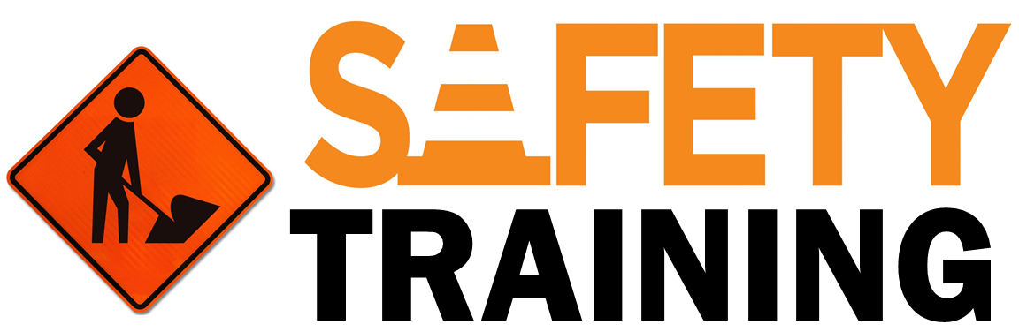

9251 Industrial Court-Suite 201, Manassas, Virginia 20109

(703) 392-7410 phone / (703) 392-7249 fax

**Toolbox Talk Communicating Issues**



Effective communication is critical to every aspect of a successful job. Being able to work safely especially relies on effective communication between everyone involved in a work task or on a job. Effective communication requires having honest conversations, which includes bringing up and discussing issues as they arise.

**Examples of Scenarios When You Should Speak Up**

There are an endless number of possible scenarios of when you should speak up and have an honest conversation to address an issue. Below are some general examples of when you need to stop and communicate an issue to get it resolved prior to continuing.

* When you see someone working unsafe.
* When you do not have the proper training or knowledge to do the task at hand.
* When you do not have the right tools or personnel to complete the task correctly.
* When a safeguard is not implemented.
* When a hazard is present that could injure you or others.

**How to Go About Communicating Issues**

* Take the time to have the conversations that need to be had to correct the situation.
* Involve the right personnel in discussions.
* If someone is working unsafe stop and have a respectful conversation about it. If you do not feel comfortable approaching them, approach a supervisor.
* Follow up conversations if necessary to ensure the situation was resolved and measures are being taken so it does not occur again.
* If necessary, ensure that others outside the immediate work group are informed of the issue and/or the corrective actions of the situation that occurred. For example, an investigation report or lessons learned report may be necessary to inform others in the company, so a similar incident does not occur again.

**Summary**

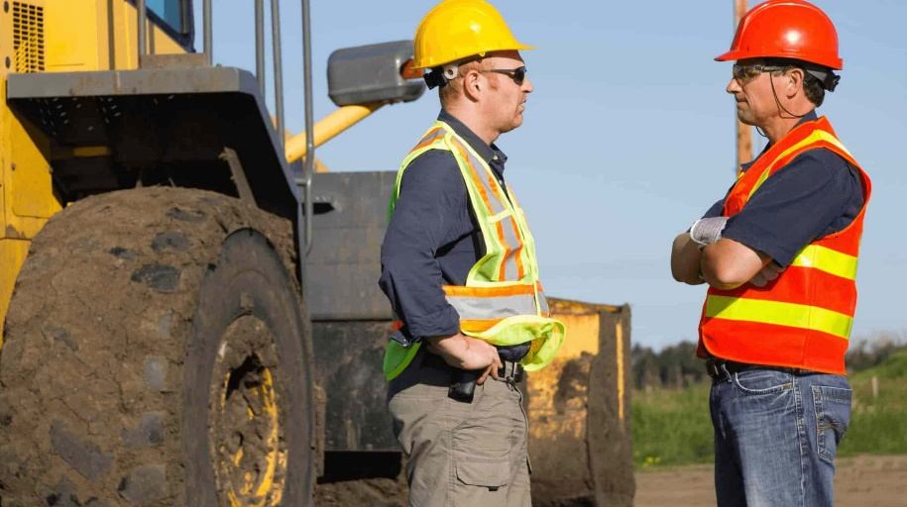

One of the most difficult things to do on the job at times is to have honest conversations. These conversations can be uncomfortable. Honest conversations about issues as they arise are critical to being able to work safely. Issues that result in individuals being at risk for injury are everyone’s problem, not just the worker who is put at risk to be injured.