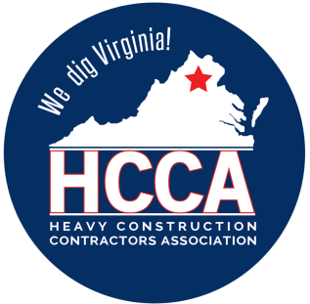 Heavy Construction Contractors Association 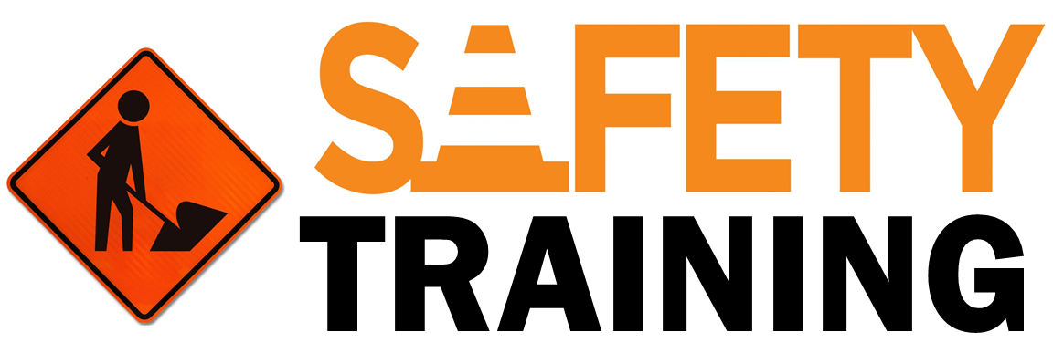

9251 Industrial Court-Suite 201, Manassas, Virginia 20109

(703) 392-7410 phone / (703) 392-7249 fax

**Toolbox Talk Work Safety During the Fall Season**



The fall season is upon us once again and in the northeastern part of the US, that means construction companies are under full pressure to complete their work before the winter season hits. The following tips are important to keep in mind as the season changes from summer to fall:

* **Three points of contact:** All equipment operators must maintain three points of contact when accessing or exiting their equipment. Fall weather brings muddy conditions, morning and afternoon dew can also present a hazard. Three points of contact at all times will help prevent operators from slipping and falling off their equipment. These types of equipment falls can often cause back strains, broken ribs, and various other lost workday injuries. Clean mud from all heavy equipment areas, including landings, stairs, and pathways; in all places where an operator is required to stand and climb. Cleaning these areas should be a task that is done every day.
* **The morning and afternoon sun** it is intense during the fall season. Heavy equipment operators should wear sunglasses at all times and should also clean their equipment glass / windows on a daily basis. It is very important for heavy equipment operators to STOP their equipment if your vision is affected at any time. If an operator cannot see 100% of his equipment, then he needs an observer to help him; bodies on the ground are no match for a great piece of equipment therefore 100% visibility is a must when moving heavy equipment.
* **Construction Work Zones** they are inherently dangerous. During the fall season, wet and slippery conditions put the traveling public, as well as the men and women working in the work zone, at additional risk.
* **Ground crew at a construction site** You must keep a safe distance from any heavy equipment. Heavy equipment can make sudden and unexpected movements due to slippery and wet conditions.
* **The fall season brings** on burnout and employee fatigue. Construction crews have completed a summer season push that consisted of tight and aggressive work schedules, including long working hours and working 5-7 days a week for months. Now these folks are expected to improve a bit to go ahead and finish the projects before the winter season. With fatigue and exhaustion comes complacency. During the momentum of the fall season, there is no room for complacency, rather there must be a renewed commitment to working safely.
* **Hypothermia:** Construction personnel should always have an extra change of clothing with them in case they get wet during the course of their workday. People can succumb to hypothermia when the air temperature reaches 50-65 ° Fahrenheit. When you add wet and muddy clothing to that, hypothermia is a real potential for staff working outdoors during the fall season. Hypothermia begins when the body temperature drops to 35 ° F (35 ° C). Obvious symptoms of hypothermia include cold, pale skin, slurred speech, and severe chills. The nervous system is the first to deteriorate; Watch for signs and symptoms.

