 Heavy Construction Contractors Association 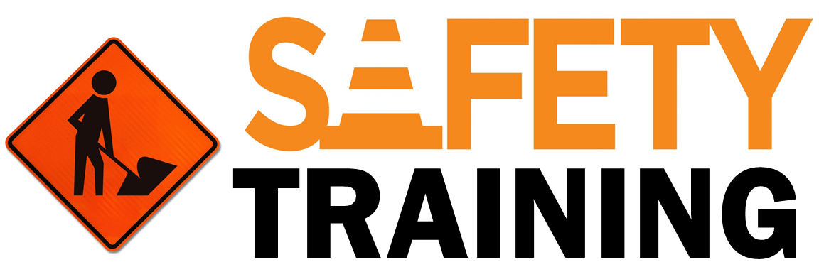

9251 Industrial Court-Suite 201, Manassas, Virginia 20109

(703) 392-7410 phone / (703) 392-7249 fax

## **Dust Hazards in Construction Safety Talk**

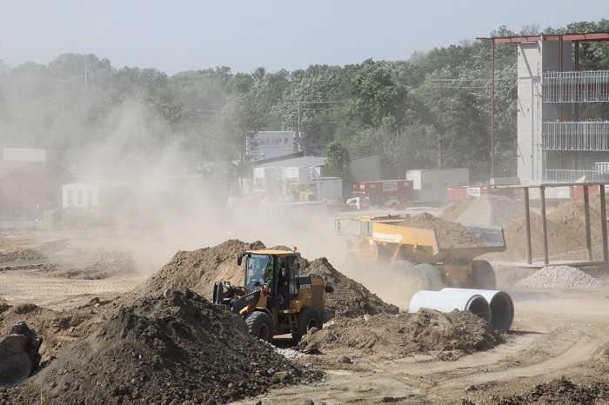

There are many different hazards on any single construction site. Dust can be one of them. Dust can cause a variety of issues from health concerns to physical hazards for workers who are exposed to it. It is important to understand the issues dust causes and what steps that should be taken to prevent its related hazards onsite.

### ****Dust Health Hazards****

### Silica Dust Exposure - Ambrose Building

According to [**a study published by WHO**](http://www.who.int/occupational_health/publications/airdust/en/), “Airborne dusts are of particular concern because they are associated with classical widespread occupational lung diseases, as well as with systemic intoxications such as lead poisoning, especially at higher levels of exposure. There is also increasing interest in other dust-related diseases, such as cancer, asthma, allergic alveolitis, and irritation, as well as a whole range of non-respiratory illnesses, which may occur at much lower exposure levels.” Dust that contains crystalline silica is also a huge issue for workers on construction sites.

[**Crystalline silica**](https://www.safetytalkideas.com/safetytalks/silica-dust/) respirable dust particles can penetrate deep into the lungs and cause disabling and sometimes fatal lung diseases, including silicosis and lung cancer, as well as kidney disease. It is never good to breathe in an excessive amount of dust, even if it is thought that no contaminants are present in it.

### ****Other Hazards Related to Dust****

Outside of the health concerns that dust can create, there are also other hazards it is responsible for. A few of these hazards include:

* Injuries to the eyes.
* It can serve as a distraction from a work task creating more risk for injury or property damage.
* Decreased visibility.

### ****Best Practices to Avoid Dust Related Illnesses and Injuries.****

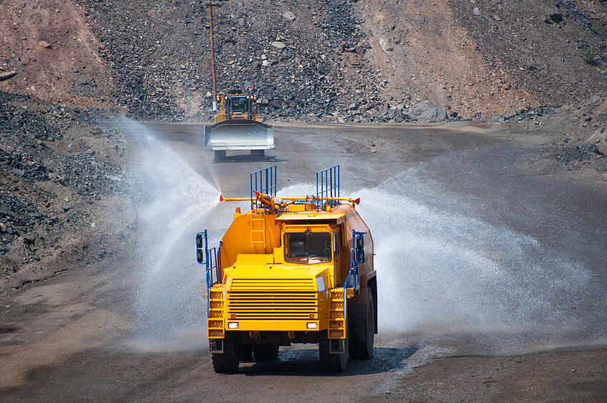

* [**Eliminate the source;**](https://www.safetytalkideas.com/safetytalks/elimination-of-hazards/)whether that is through engineering controls or a change in work processes.
* Use collection or vacuum systems on tools that create dust to collect it at the point of operation.
* Use wet methods when cutting or breaking any concrete or similar materials.
* Use water as a means of suppression on roadways or in work areas.
* Have trucks and equipment keep speeds down if dusty conditions are present onsite.
* Stay out of areas where dust levels are high as well as avoiding being downwind from these areas.
* Use proper respirators when engineering controls are not enough to protect you.

### ****Summary****

Consider the hazards dust creates onsite. Realize the health issues it can create as well as the physical hazards. Elimination is the best way to protect yourself from dust or any other hazard onsite for that matter.

### ****Discussion point:****

1. How can we reduce our exposure to dust at this worksite?