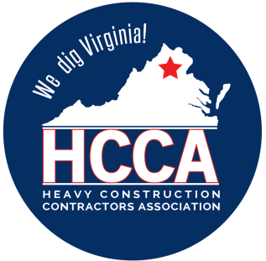 Heavy Construction Contractors Association 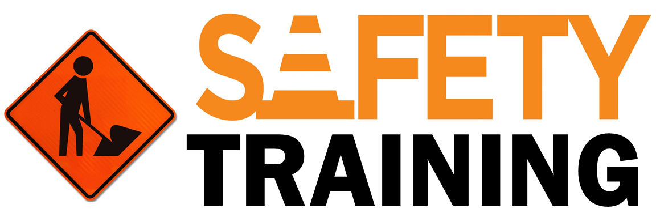

9251 Industrial Court-Suite 201, Manassas, Virginia 20109

(703) 392-7410 phone / (703) 392-7249 fax

# Toolbox Talk The Deadly Dozen

# We all know that there must be a cause for an accident to happen. In order to avoid accidents, we must remove the cause. Every cause is a result of an unsafe act or unsafe condition. By recognizing the unsafe act or condition, we can effectively remove the exposure to them. The following “deadly dozen” are reminders to help you recognize unsafe acts or conditions.

### Guide for Discussion

*Unsafe Acts*

1. Unauthorized use or operation of equipment.
2. Failure to secure or tie down materials to prevent unexpected movement.
3. Working or operating equipment too fast.
4. Failure to issue warnings or signals as required.
5. Using defective tools or equipment.
6. Removing guards.
7. Improperly using tools or equipment.
8. Standing in an unsafe place or assuming an improper posture (as in lifting).
9. Servicing moving equipment.
10. Riding equipment not designed for passengers.
11. Horseplay.
12. Failure to wear the proper personal protective equipment.

*Unsafe Conditions*

1. Lack of proper guards.
2. Lack of a proper warning system.
3. Fire and explosion hazards.
4. Poor housekeeping.
5. Unexpected movements.
6. Protruding objects such as nails, wire, or other metals.
7. Improper clearance or congestion at aisles or passageways.

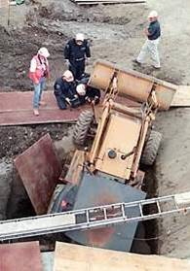

1. Poor placement, storage or arrangement of materials.
2. Hazardous tools, equipment or materials.
3. Poor lighting, high noise levels.
4. Hazardous atmospheric conditions.
5. Improper personal attire.

### Additional Discussion Notes:

**Remember:** Be able to recognize the conditions or acts we just discussed, you can effectively correct or avoid them and reduce your personal exposure to the general causes of accidents.