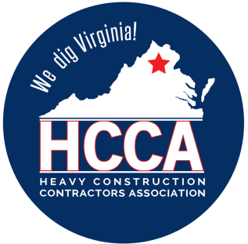 Heavy Construction Contractors Association 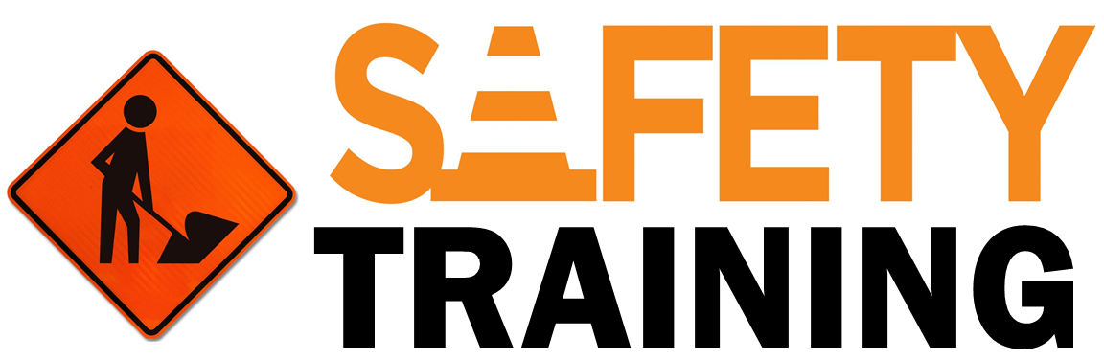

9251 Industrial Court-Suite 201, Manassas, Virginia 20109

(703) 392-7410 phone / (703) 392-7249 fax

**Work Area Best Practices Safety Talk**

Often times much of our focus is given to the hazards of a work task, but less focus is given to the hazards poor work area conditions create.

Work areas that are chaotic and that have poor organization can lead to more injuries and property damage incidents. It is important to consider what improvements we can make to our work areas to create a safe work environment.

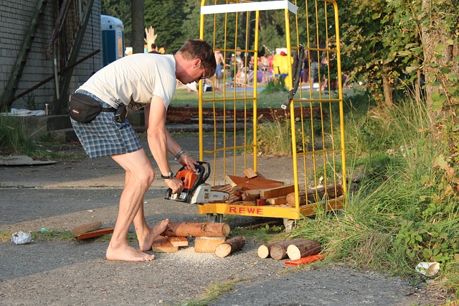

### ****Hazards Created by Chaotic Work Areas****

* Struck-by incidents- Work areas that do not have any designated paths for personnel walking through or areas blocked off for specific work tasks such as grinding, create struck-by hazards can be particularly dangerous. Flying debris, lifting loads, and moving objects can all [**create struck-by hazards**](https://www.safetytalkideas.com/safetytalks/struck/)for anyone in the area.
* Slips, trips, and falls- Objects on the ground due to poor organization or housekeeping create trip hazards for any walking through that area. Slippery surfaces due to moisture or other liquids such as oil can cause a slip or a fall. Uneven surfaces, steps, or unexpected drop-offs are also a common trip hazards in poorly designed work areas.
* Caught in or between incidents- Work areas that place people near moving parts or equipment is also a huge concern. Moving equipment such as belts or fans can grab a hold of a person’s clothing or hair pulling them into the moving parts.

### ****Best Practices for Work Area Setup****

### Delineate walking paths from actual work areas. Consider when physical barriers such as a fence or wall are needed to protect people from a hazardous work process. [Consider color coding](http://www.rodem.com/sites/default/files/asset/document/Benefits%20Of%20And%20How%20To%20Color-Code%20In%20Your%20Facility_0.pdf)for work areas or the facility as a whole.

* Organize all tools, equipment, materials, etc. in an area. Everything should have its own place that does not pose a hazard to anyone in that area. [**Housekeeping**](https://www.safetytalkideas.com/safetytalks/housekeeping-construction-industry/) is one of the most basic safe work practices there is.
* Always guard moving parts and equipment even when they are not in the immediate planned walking path. If people can fit into an area and the moving parts are not physically blocked off there is a chance of a caught in or between injury.
* Keep walking and working surfaces kept up and safe. Mark any elevation changes with bright fluorescent paint. Patch any holes or major cracks to prevent trip hazards. Always strive to keep dry clean floors. Consider applying some type of grit or material that improves traction in areas where moisture can occur.

### ****Summary****

The above hazards and best practices are just a few of the many that are related to how a work area is setup and maintained. What hazards are we not addressing in our work areas? What improvements can we make today and in the future to create a safer workplace? What other hazards and best practices are out there?