 Heavy Construction Contractors Association 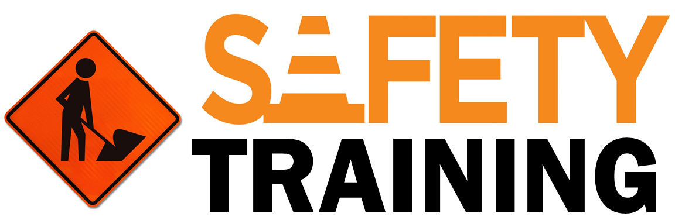

9251 Industrial Court-Suite 201, Manassas, Virginia 20109

(703) 392-7410 phone / (703) 392-7249 fax

**“ToolBox Talk Avoiding Unsafe Acts & Conditions”**

There are times of the year, such as the holidays or different weather seasons, when more workers tend to get hurt because of the additional pressure placed on them. Weather it is getting the kids gifts, packing for a summer trip, or preparing for holidays gatherings, these events can cause major distractions in the workplace because workers have things other than work in their mind.

It is important during these times to keep your mind on the job and be aware of the unsafe conditions and unsafe acts.

**Identifying and Preventing Unsafe Conditions & Acts**

An **“Unsafe Condition”** is anything at the workplace that is likely to cause property damage or injury.

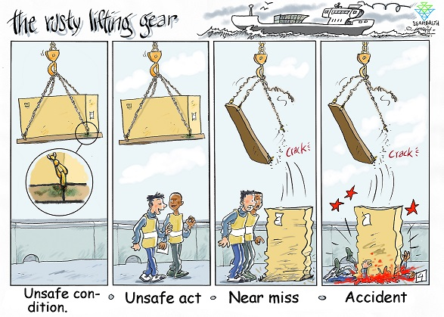

Unsafe conditions exist all around us. Simply driving a car puts each one of us in a condition where we are vulnerable to accidents. We are surrounded by hazards that could cause harm, but most of the time we safely negotiate these hazards and arrive at our destination safely. The same is true of unsafe conditions at the workplace.

An **“Unsafe Act”** is any action taken during the performance of a task or other activity that is conducted in a manner that may threaten the health and/or safety of yourself or other workers.

Unsafe acts are more difficult to recognize and correct because they involve human factors. They are linked to our behavior. For example, driving in the snow creates an unsafe condition to drive in, but the hazard is magnified when someone drives in the snow without slowing down or maintaining safe distances. These acts make the unsafe condition even worse.

Unsafe acts are not tied to a worker’s skill level. Some of the most skilled employees might actually display some of the dangerous behaviors. In fact, some studies have shown that the more skilled a worker becomes, the more likely they are to develop unsafe habits.

Make sure, especially when life gets busy and hectic, that you take the time to check your conditions and actions, ensuring a safer workplace for you and your coworker.

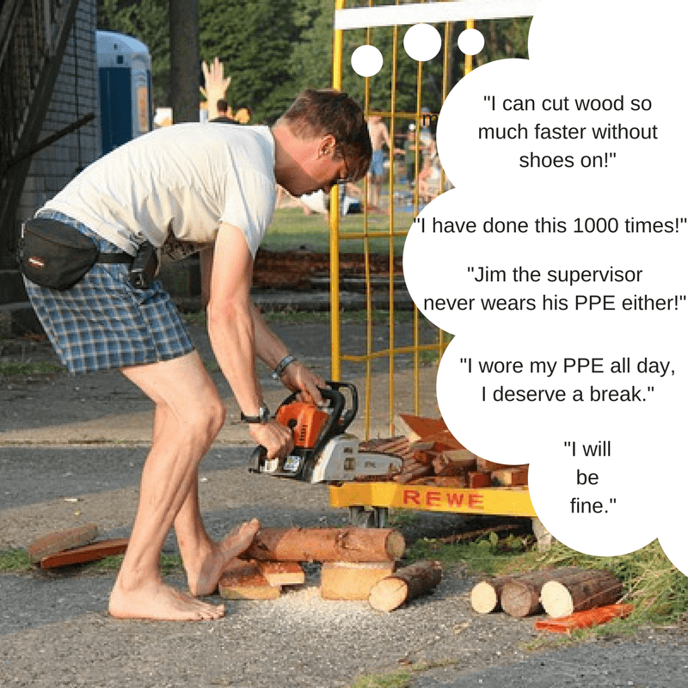

|  |  |
| --- | --- |
| **Examples of Unsafe Acts**   * Operating equipment without qualification or authorization * Lack of or improper use of personal protection equipment * Operating equipment at unsafe speed * Failure to warn * Bypass or removal of safety devices * Using defective equipment | **Examples of Unsafe Conditions**   * Defective tools, equipment, or supplies * Inadequate supports or guards * Overcrowding in the workplace * Inadequate warning systems * Fire and explosion hazards * Poor housekeeping * Hazardous atmospheric conditions |

**I will not let busy seasons affect the safety of myself or my coworkers. I will continue to check my surrounding conditions and actions for risks.**