 Heavy Construction Contractors Association 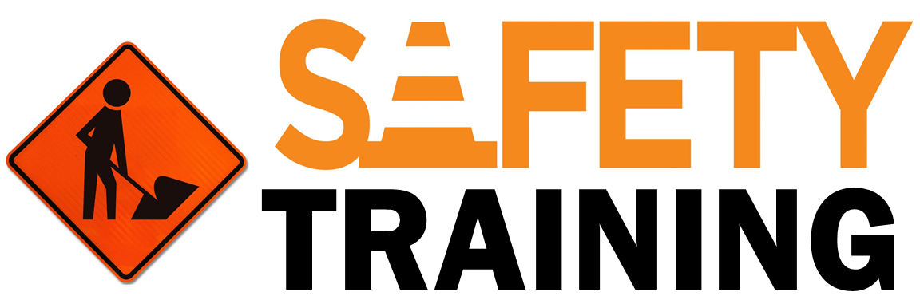

9251 Industrial Court-Suite 201, Manassas, Virginia 20109

(703) 392-7410 phone / (703) 392-7249 fax

***Toolbox Talk – Heat Stress***

Living in Virginia, we have become accustomed to dealing with extreme temperature fluctuations. With this toolbox talk we will define heat stress and look at the various heat induced illnesses and how to prevent/treat heat stress.

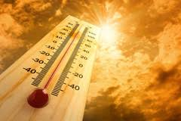

# What is Heat Stress:

* Heat stress occurs when the body is unable to cool itself by sweating.
* Heat stress can lead to heat exhaustion or heat stroke.

# Symptoms of Heat Exhaustion:

* Headache, dizziness, lightheadedness, fainting
* Weakness and moist skin
* Mood changes, irritability, confusion
* Nausea, vomiting

# Symptoms of Heat Stroke:

* Dry, hot skin with no sweating
* Mental confusion or loss of consciousness
* Seizures or convulsions
* Can be fatal

# Preventing Heat Stress:

* Know signs/symptoms of heat related illnesses
* Block out sun or other heat sources
* Use fans/A.C. units
* In high heat, drink 1 cup of water every 15 minutes
* Wear lightweight, light colored, loose fitting clothes
* Avoid alcohol, caffeinated drinks, or heavy meals
* Wear sunscreen of SPF 15 or >; reapply every 2 hours

# 

# How to Treat Heat-Related Illness

* Seek immediate medical attention; call 911

# While Waiting

* Move worker to cool shaded area
* Loosen or remove heavy clothing
* Provide cool drinking water
* Fan and mist person with water