 Heavy Construction Contractors Association 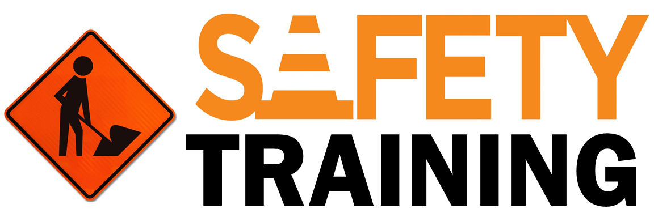

9251 Industrial Court-Suite 201, Manassas, Virginia 20109

(703) 392-7410 phone / (703) 392-7249 fax

**T*oolbox Talk*** [***Slips Trips and Falls***](https://www.constructioncenterofexcellence.com/toolbox-talks/slips-trips-and-falls)

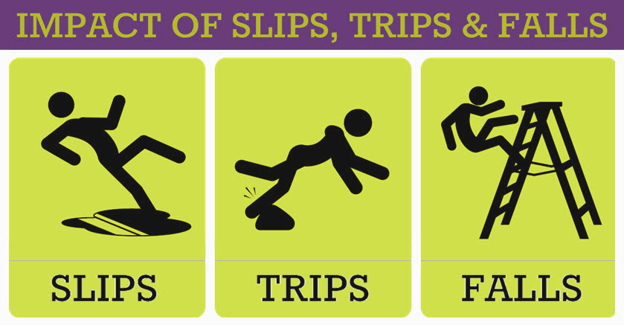

Slips, trips and falls are a leading cause of injury in the country. More workers are hurt due to slips, trip or falls than any other reason. Thousands of disabling injuries, even deaths, occur each year as a result of slips, trips, and falls from heights, on stairs, and even at ground level.

* Items left on the ground and not placed in a safe position can cause a trip hazard.
* General debris such as concrete rubble, lumber or plastic sheeting can quickly accumulate to cause a trip hazard
* If lighting levels are reduced, tripping hazards are easily increased.
* Mud left on ladder rungs, will be a slip / fall hazard for yourself and or the next user.

**At Work and At Home**

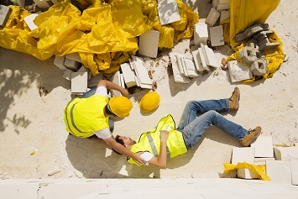

**Housekeeping is a key element**.

* Maintain our work areas to prevent slips, trips, and falls.
* Keep walkways, aisles, and stairs free of tools, materials, and other hazards.
* Clean up any leaks or spills on floors, stairs, entranceways, and loading areas promptly.
* Repair or report floor problems, such as broken planks, missing tiles, etc.
* Block off and mark floor areas that are being cleaned or repaired.
* Keep cords, power cables, and air hoses out of walkways.
* Place trash promptly in proper containers.
* Report missing or broken stair rails and slippery or damaged treads.
* Setup ladders on level surfaces and do not over reach or over extend yourself.
* Properly cover and secure floor and wall openings
* Walk, don't run, on stairs. Hold onto stair rails while going up and down.
* Inspect walkways before lifting and carrying something if your visibility to the ground is going to be obstructed.
* Do not jump on or off platforms and loading docks, and stay away from edges.
* Do not carry a load you can't see over, especially on stairs or around dock edges.
* Be wary of water, ice and snow.
* Wear appropriate footwear that is in good condition.

Watch where you are going while walking—pay attention and do not get distracted. Reading, writing, texting and similar tasks while walking is not safe behavior.

**Paying attention to things around you like ladders, floor openings, stairways and good housekeeping will prevent slips, trips, and falls.**