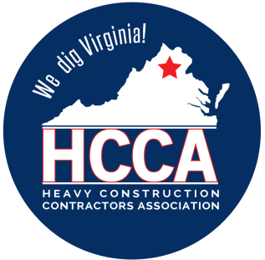 Heavy Construction Contractors Association 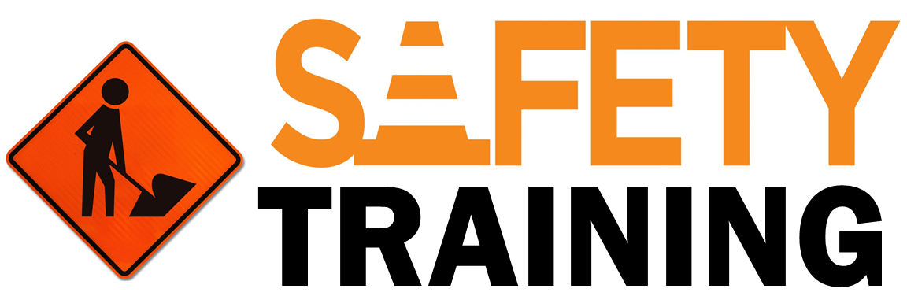

9251 Industrial Court-Suite 201, Manassas, Virginia 20109

(703) 392-7410 phone / (703) 392-7249 fax

**TOOLBOX TALK WORK ZONE SAFETY**

At one time or another, all drivers encounter the unfamiliar traffic patterns and hazards posed by roadway work zones. A highway worker or motorist is killed in a roadway construction zone every 8 hours. More than 50,000 Americans - enough to fill most major league baseball and football stadiums in the United States- are also injured in construction zone accidents each year.

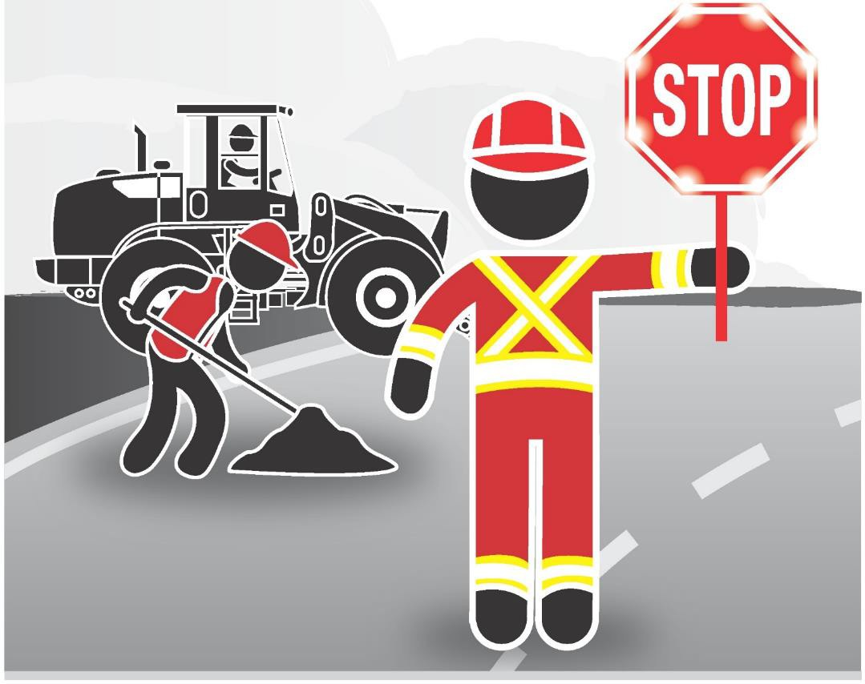

FHWA analysis of the 1,079 motor vehicle work zone fatalities in 2001 revealed:

* 85 percent of all fatalities were motor vehicle drivers or occupants.
* 70 occurred on roads with speed limits of 55 miles per hour or greater.
* Rear-end crashes (running into the rear of a slowing or stopping vehicle) was the most common type of work zone crash.
* 249 occurred in crashes involving large trucks.

# Remember This

To reduce their risk of injury from road traffic, workers and crew leaders can take the following actions:

* Train ALL workers in proper traffic control techniques, and how to work next to motor vehicle traffic.
* Wear high visibility clothing with a fluorescent background or reflective materials, including vests, arm bands, or hats.
* Be aware of your surroundings, and identify potential hazards.
* Stay out of lanes or areas where walking is prohibited.
* Make sure you are aware of and understand hand and other communication signals that will be used on the jobsite.
* Listen for reverse-signal alarms.
* Ask your supervisor about closing the road, rerouting to control traffic, or setting up barriers (concrete is more protective than cones).
* Have a traffic control expert walk or ride through the jobsite to look for evidence of near-misses, such as skid marks or damaged barricades.
* Use traffic control devices such as signs, warning signals, paddles, and concrete barriers consistently throughout the entire work area.
* Have flaggers use devices that increase their visibility. For example, a flashing Slow/Stop paddle with a mounted strobe light has been found to be effective.
* Wear high visibility clothing with a fluorescent background or reflective materials, including vests, arm bands, or hats.
* Be aware of your surroundings, and identify potential hazards.
* Listen for reverse-signal alarms.
* Ask your supervisor about closing the road, rerouting to control traffic, or setting up barriers (concrete is more protective than cones).
* Have flaggers use devices that increase their visibility, such as a flashing Slow/Stop paddle with a mounted strobe light.

**Expect the unexpected.**

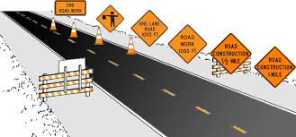 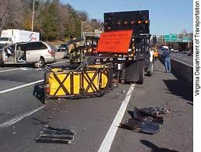

When you drive or work in work zones, it’s always best to prepare yourself for something unexpected, such as aggressive actions by other motorists, construction vehicles that slow down to leave the roadway and pull into the work area, dump trucks that emerge from the work area and enter your lane up ahead, workers operating scant inches from your path, uneven pavement lanes, and loose gravel on the road surface to name just a few. When you anticipate problems, you are better able to react to them appropriately.

**Don’t lose your patience or your temper. If you keep your cool, you and everyone else will make it through the work zone and arrive safely at their destinations.**