 Heavy Construction Contractors Association 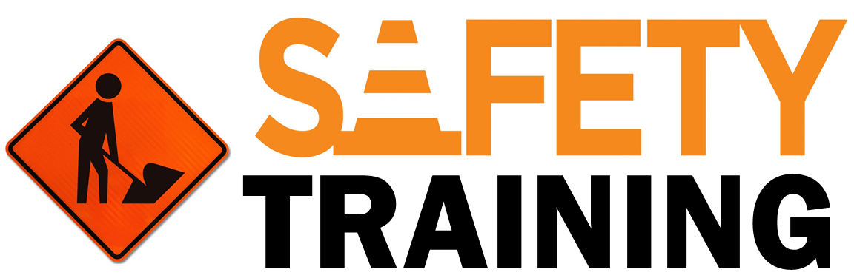

9251 Industrial Court-Suite 201, Manassas, Virginia 20109

(703) 392-7410 phone / (703) 392-7249 fax

**TOOLBOX TALK - MACHINE GUARDING**

This Toolbox Talk is based on OSHA’s machine guarding standards. Guarding involves

protecting ourselves from machines and equipment in our work environment.



**Basic Terminology:**

*Parts of the Machine Requiring Guarding*

•  **Point of Operation:** Area where machine performs work on material

•  **Power Transmission Apparatus:** Belts, gears, flywheels, chains, pulleys,

spindles, couplings, cams, machine components that transmit energy.

•  **Other Moving Parts:** Reciprocating, rotating, traversing motions, auxiliary

machine parts.

 **Types of Mechanical Motion that Must be Guarded:**

•  **Pinch Points**: Points at which it is possible to be caught between

moving parts, or between moving and stationary parts of

a piece of equipment

•  **Rotating:** Circular motion of shafts with a protrusion sticking out can grip

clothing or pull body part into point of operation

•  **Reciprocating:** Back-and-forth or Up-and-Down motion that may trap/

strike an employee between the moving object and a fixed object.

•  **Traversing:** Movement in straight, continuous line that may strike or

catch an employee in a pinch or shear point between a moving and fixed

object.

•  **Cutting:** Action of sawing, boring, drilling, milling, slicing

•  **Punching:** Action resulting when a machine moves a slide (ram) to stamp

a sheet of metal or other material.

•  **Shearing:** Movement of a powered slide or knife during metal trimming

or paper cutting

•  **Bending:** action occurring when power is applied to a slide to draw or

form metal or other materials

 **Group Discussion Topics:**

•  Identify the machines in your job that you use that require machine guarding.

•  How could someone be injured by using these machines? How can this be prevented?

•  Inspect your machines to ensure the guards are correctly positioned, intact and in place.