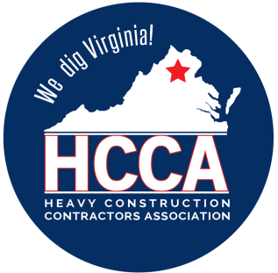 Heavy Construction Contractors Association 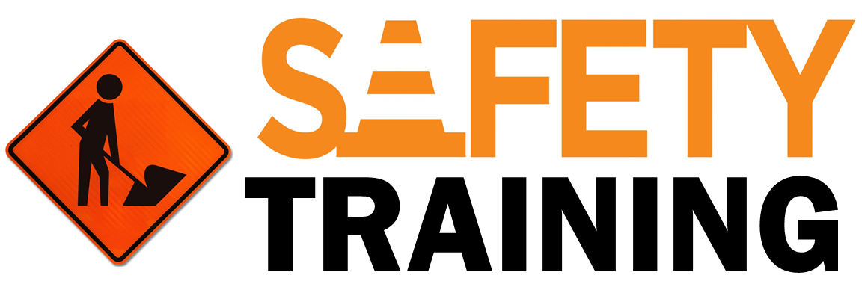

9251 Industrial Court-Suite 201, Manassas, Virginia 20109

(703) 392-7410 phone / (703) 392-7249 fax

**TOOLBOX TALK PERSONAL PROTECTIVE EQUIPMENT (PPE)**



Follow these six PPE guidelines to stay safer on the job:

**PPE SHOULD BE THE LAST LINE OF DEFENSE**

The first two lines of defense against safety hazards should be engineering and administrative controls. Only after deploying both of these should PPE be used to guard against safety hazards.

**PPE MUST FIT AND BE WORN PROPERLY**

PPE that is too large or too small may not properly protect you from hazards and could create additional hazards. Wearing improper PPE could subject you to harm.

**REUSABLE PPE MUST BE KEPT CLEAN AND WELL-MAINTAINED**

Reusable PPE should be cleaned after each use and inspected before every use to ensure that it is still in good working order.

**PPE DOESN’T LAST FOREVER**

Worn out PPE may not provide the proper protection and can become a hazard. Replace PPE when it shows visible signs of wear or when test data shows that it is no longer serviceable.

**PPE ONLY PROTECTS YOU WHEN YOU’RE WEARING IT**

Even the most expensive, highest quality PPE won’t protect you if it’s not on your body and properly applied.

**STAY CAUTIOUS WHILE WEARING PPE**

No piece of PPE will protect you against every workplace hazard. That’s why there are so many types and styles. Each one protects you from different types of hazards. No matter what PPE you wear, it is still essential to follow the safety procedures that have been established by your employer.

**Note to Workers:** Don’t be afraid to ask questions about the PPE you are wearing and never hesitate to replace PPE that is worn out or does not fit well. It is your employer’s responsibility to explain workplace hazards and provide safeguards, including engineering and administrative controls and PPE. It is your job, however, to make sure that it

is worn properly and fits well.