5

 Heavy Construction Contractors Association 

9251 Industrial Court-Suite 201, Manassas, Virginia 20109

(703) 392-7410 phone / (703) 392-7249 fax

**Toolbox Talk - Defensive Driving**

Defensive driving is the art of driving so as to prevent and avoid traffic crashes, regardless of the unsafe conditions and actions created by other drivers and adverse road and or weather conditions.

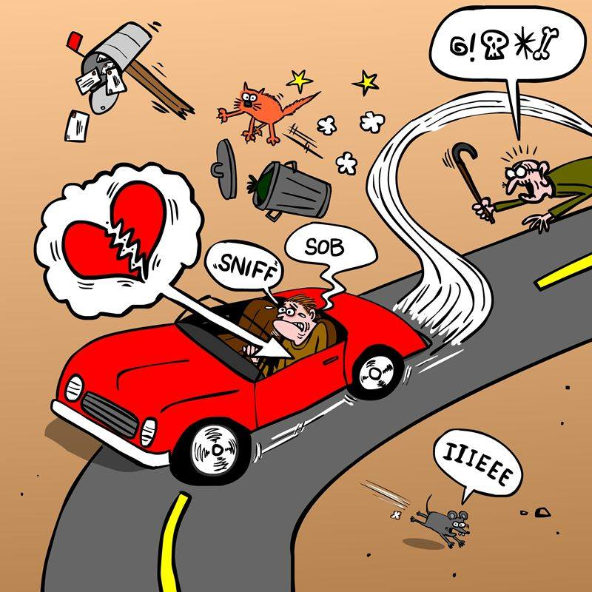

A good defensive driver will practice the following eight techniques:

* Glance well ahead in the direction of travel. Look 2 or 3 vehicles ahead to observe driving conditions in front of you. This allows you to consider a condition before you reach it.
* Get the “big picture”; learn to see the entire roadway. Sweep the scene, sides and back. Avoid “tunnel vision”. Keep your eyes moving; Position vehicle slightly offset to traffic to increase your field of vision.
* Always allow an escape route, leave a cushion by slowing or moving ahead of the vehicles beside you.
* Keep your vehicle visible and signal your intentions early.
* When stopped prior to making left turns across incoming traffic leave wheels straight to prevent being pushed into oncoming traffic in the event of a rear-end crash.
* When entering intersections practice looking left/right/left. Be sure to come to a full stop before proceeding.
* Learn to compensate for hazards such as weather, debris, potholes, loose gravel, or sand.
* ALWAYS maintain a cautious driving attitude.

**Distractive Driving**

Distraction occurs any time you take your eyes off the road, your hands off the wheel, and your mind off your primary task: driving safely. Any non-driving activity you engage in is a potential distraction and increases your risk of crashing. Distracted driving is any activity that could divert a person's attention away from the primary task of driving.

All distractions endanger driver, passenger, and bystander safety. These types of distractions include:

* Texting
* Using a cell phone or smartphone
* Eating and drinking
* Talking to passengers
* Grooming
* Reading, including maps
* Using a navigation system
* Watching a video
* Adjusting a radio, CD player, or MP3 player There are three main types of distraction:
* Visual — taking your eyes off the road
* Manual — taking your hands off the wheel
* Cognitive — taking your mind off what you’re doing

Texting is the most alarming distraction because it involves manual, visual, and cognitive distraction simultaneously. Sending or reading a text takes your eyes off the road for 4.6 seconds. At 55 mph, that's like driving the length of an entire football field, blindfolded. It's extraordinarily dangerous.

**DO - Stay Safe:**

* Use a seat belt at all times – driver and passenger(s).
* Adjust your driving for the conditions, including traffic, weather, pedestrians, rough roads and degree of light.
* Drive defensively.
* Use a hands-free device for phone use if you have to use the phone while driving.
* Be well-rested before driving.
* Avoid taking medication that makes you drowsy before driving, including prescription and over the counter drugs.
* Set a realistic goal for the number of miles that you can drive safely each day.

**DO - Stay Focused:**

* Driving requires your full attention. Avoid distractions, such as adjusting the radio or other controls, eating or drinking, and talking or texting on the phone.
* Continually search the roadway to be alert to situations requiring quick action.
* Stop about every two hours for a break. Get out of the vehicle to stretch, take a walk, and get refreshed.
* Be patient and courteous to other drivers.
* Reduce your stress by planning your route ahead of time (bring the maps and directions), allowing plenty of travel time, and avoiding crowded roadways and busy driving times.
* Adjust your speed and increase your following distance when carrying heavier than normal loads and when you are towing.

**DON’T:**

* Drive under the influence of drugs and or alcohol.
* Drive aggressively.
* Tailgate or speed.
* Take other drivers’ actions personally.
* Text and drive.
* Enter data in your GPS while driving