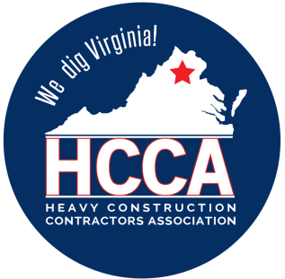 Heavy Construction Contractors Association 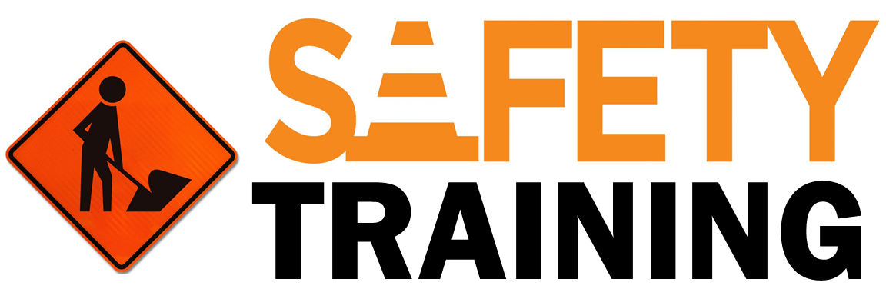

9251 Industrial Court-Suite 201, Manassas, Virginia 20109

(703) 392-7410 phone / (703) 392-7249 fax

**Toolbox Talk - Safety Is Common Sense**



*Note to Supervisor: This 5-Minute Toolbox Talk is designed not only to communicate important safety information to your employees, but also to be given to them by you, which will hopefully reinforce the message and let them know your expectations for safety. You can use the text below as a script to be rendered verbatim or just as talking points to be stated in your own words.*

According to safety professionals, four of five serious injuries are the result of workers not being sensible on the job and taking unnecessary chances. Common sense on the job is irreplaceable. Most of us have worked around people that are accident prone. They aren’t jinxed; they aren’t very common sense smart. Today we want to talk about using common sense to avoid accidents in the workplace.



**Common Sense “Smarts”**

* Always wear the proper personal protective equipment.
* Don’t over exert yourself – get help with heavy tasks.
* Don’t over extend yourself when on ladders – and risk losing your balance.
* Always use the proper tool for the job.
* Concentrate on your work.
* Look for unsafe acts or unsafe working conditions – and then report them.
* Watch out for others – remember you are part of a team.

**Ask the following questions before you begin to work:**

* Are the conditions safe to do the work?
* Are the methods we are going to use safe?
* Does everyone know what to do?
* Does everyone know how to do it?
* Can I fall, get struck by, get caught between or under, or get electrocuted on this job?

**Remember:** By remembering and following common sense rules and by asking yourself about the conditions, methods, job site hazards and knowing what to do, you should be able to decrease your chances of being injured. Be “common sense smart” and prevent accidents, not cause them.