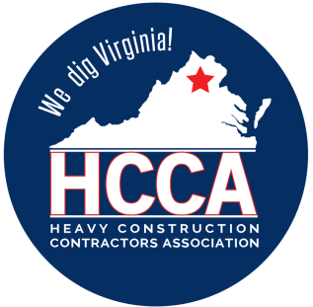 Heavy Construction Contractors Association 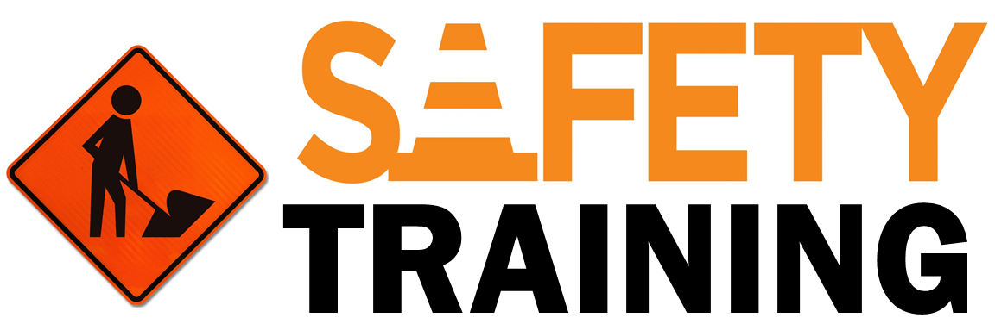

9251 Industrial Court-Suite 201, Manassas, Virginia 20109

(703) 392-7410 phone / (703) 392-7249 fax

***Toolbox Talk – Safe Work Habits***

*Note to Supervisor: This 5-Minute Toolbox Talk is designed not only to communicate important safety information to your employees, but also to be given to them by you, which will hopefully reinforce the message and let them know your expectations for safety. You can use the text below as a script to be rendered verbatim or just as talking points to be stated in your own words.*

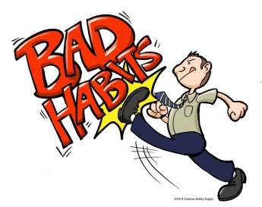

In most everything we do, we find a "trick" to make the process easier and faster. After we develop these tricks, they become work habits in our everyday activities. Developing everyday safety habits can keep you injury-free through the year. Here are some safe work habits to live by:

1. ***Stay Alert (and Stay Alive)*.** The more alert, awake and aware you are, the more likely that you will be able to recognize hazards and unsafe conditions and the less likely that you will get hurt as a result of them.
2. ***Set Your Own Standards*.** Don't be influenced by others around you who are negative. If you fail to wear safety glasses because others don't, remember that the blindness you may suffer will be yours alone to live with.
3. ***Operate Equipment Only if Qualified*.** Your supervisor may not realize you have never done the job before. You have the responsibility to let your supervisor know so that the necessary training can be provided.
4. ***Respect Machinery*.** If you put something in a machine's way, it will crush it, pinch it or cut it. Make sure all guards are in place. Never hurry beyond your ability to think and act safely. Remember to de-energize the power first before placing your hands in a point of operation.
5. ***Use the Right Tools.*** If you need a hammer, get a hammer. If you need a pry bar, get one of those. It may be handier to use a pair of pliers, wrench, screw driver or your fist instead of the right tool, but you have only yourself to blame if you hurt yourself or someone else because you used a tool to do something for which it was not designed.
6. ***Use Your Own Initiative for Safety Protection*.** You are in the best position to see problems when they arise. Ask for the personal protective equipment or additional guidance you need. Never fail to report accidents, defective equipment or unsafe conditions.
7. ***Ask Questions*.** If you are uncertain, ask. Do not accept answers that contain, "I think, I assume, I guess." Be sure. If you unsure how to operate equipment or perform a task safely, ask your supervisor or someone who knows how. Don’t guess and muddle through. Make sure you know in advance the correct, safe way to do it.
8. ***Use Care and Caution When Lifting*.** Most muscle and spinal injuries are the result of overstraining. Know your limits. Do not attempt to exceed them. The few minutes it takes to get help will prevent weeks of being off work and in pain.
9. ***Be Tidy—Practice Good Housekeeping.*** Disorganized work areas are the breeding grounds for accidents. You may not be the only victim. Don't be a cause. Always put away tools when they are not in use. Keep the floors clean, pick up scraps and wipe up spills. A slip or trip can be fatal.
10. ***Wear the Right Clothes.*** Wear sturdy and appropriate footwear that encloses the foot fully. Avoid loose clothing, dangling jewelry, and be sure that long hair is tied back. Anything that can catch in machinery or trip you up is hazardous. Wear protective clothing and equipment as required.
11. ***Practice Good Personal Cleanliness*.** Avoid touching eyes, face, and mouth with gloves or hands that are dirty. Wash well and use barrier creams when necessary. Most industrial rashes are the result of poor hygiene practices.
12. ***Get First Aid Immediately*.** If you are hurt while on the job, even if it is just a scratch, be sure to report it and get it treated immediately. Neglect of an injury may lead to serious infection, weeks of lost time and even permanent injury.
13. ***Be a Positive Part of the Safety Team*.** If you have an idea you believe will improve safety, tell your supervisor or the Safety & Risk manager about it. Set the example by willingly accepting and following safety rules. Encourage others to do so and look out for them. Your attitude can play a major role in the prevention of accidents and injuries.
14. ***Never Take a Chance*.** Next to sheer carelessness, taking a short cut is probably the biggest killer of all. To save a minute or two, you may lose a lifetime. Whatever you are doing, if you are not doing it safely, you are not doing it right. Always remember that no job is so important or so time-critical that you can’t take the time to do it safely.