 Heavy Construction Contractors Association 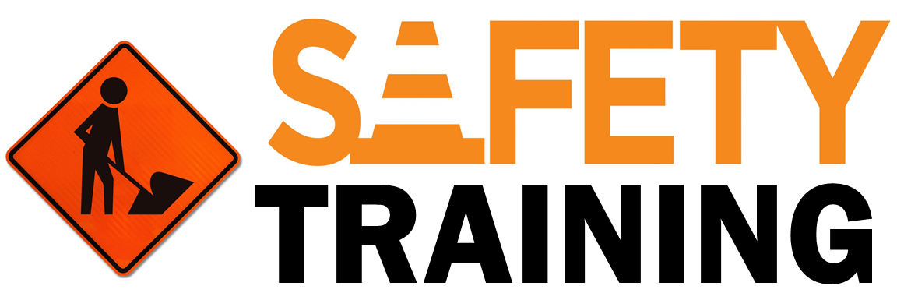

9251 Industrial Court-Suite 201, Manassas, Virginia 20109

(703) 392-7410 phone / (703) 392-7249 fax

***TOOLBOX TALK Driving on Snow and Ice: 10 Safety Tips***

The best tips for winter driving are to simply slow down and proceed with extreme caution. Operating a motor vehicle on a bright sunny day is hazardous enough, but add snow and ice and the hazards increase. In fact, according to the Bureau of Labor Statistics at one time vehicular accidents were the leading cause of all occupational fatalities. However, deaths as a result of falls have now surpassed vehicular accidents. While they are no longer the number one cause of fatalities, vehicular accidents still occur far too frequently, and the risk is compounded when snow and ice become part of the equation. Here are 10 safety tips that can help prevent an accident while driving on snow and ice:

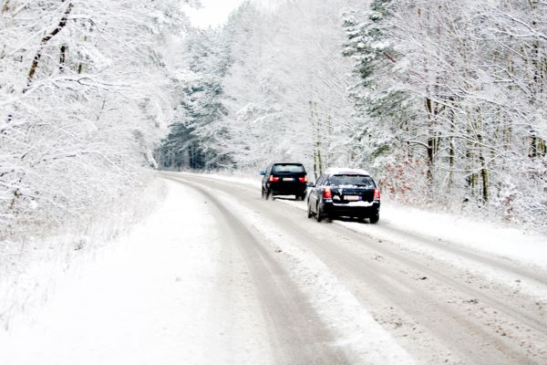

**1. Get a grip**. Tire traction is critical. Prior to driving on snow and ice check your tires for tread. To have adequate snow traction, a tire requires at least 6/32-inch deep tread.

**2.** **Make sure you can see**. Replace windshield wiper blades. Clean the inside of your windows thoroughly. Make sure your windshield washer system works and is full of an anti-icing fluid.

**3. Run the defroster**. In order to remove condensation and frost from the interior of windows, engage your defroster. It is critical during snowy and icy weather that the windshield remains warm. It not only helps inside the car but can help to prevent build up on the outside of the windshield

**4. Check your lights**. Use your headlights so that others will see you. It is important to ensure that your headlights and taillights are clear of snow.

**5. Give yourself a brake**. Utilizing your brakes properly on snow and ice can be the difference between sliding out of control and maintaining a safe position on the road. It is sudden stops and applying the brakes unnecessarily that can lead to loss of control of your vehicle.

**6. Watch carefully for "black ice."** If the road looks slick, it probably is. This is especially true with one of winter's worst hazards: "black ice." Also called "glare ice," this is nearly transparent ice that often looks like a harmless puddle or is overlooked entirely.

**7. Remember the tough spots**. Recognizing where roads can become slick and icy can be half the battle. Bridges and overpasses are common places that will freeze first. When encountering bridges and overpasses it is important to keep acceleration and braking to a minimum.

**8. Control your steering**. Once your tires lose traction on the road and you are working to regain control of your vehicle, steering becomes an integral part of keeping your vehicle safely on the road. It is very important during a skid to steer the vehicle back to your desired direction.

**9. Control your speeds**. Operating a motor vehicle at a safe speed during snow and icy conditions is the one thing that we all can do to avoid most hazardous situations. It is important to remember to slow down to the level of the conditions of the road and brake early.

**10. Technology and the size of the vehicle offer no miracles**. Most drivers think that large trucks and SUVs offer a higher level of protection than smaller vehicles. The fact of the matter is, large trucks and SUVs are equally as vulnerable as other vehicles on snow and ice and could end up in the same ditch as a sedan.

Regardless of your driving skill or vehicle preparation, caution and respect for the conditions are key to avoiding an accident. These tips may help prevent snowy and icy roads from ruining your day.