 Heavy Construction Contractors Association 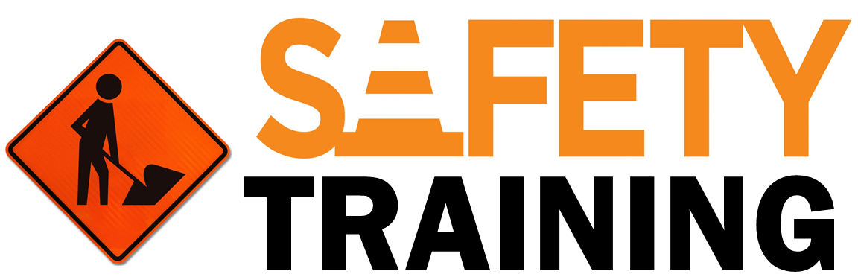

9251 Industrial Court-Suite 201, Manassas, Virginia 20109

(703) 392-7410 phone / (703) 392-7249 fax

***Toolbox Talks Personal Rights & Responsibilities***

**Introduction**

Collective responsibility that makes exercising rights possible. If nobody assumes responsibility,

then the right to a safe workplace exists only as a lofty ideal. Fortunately, governments and health and safety committees are acting to make the safe workplace an everyday reality for workers everywhere.

**Worker Rights**

Workers everywhere have both rights and responsibilities, and you really can’t have one without

the other. The following is a list of your rights as a worker:

1. **You have the right to know about actual or potential dangers in the workplace.** Your employer is obligated to tell you about the hazards of all material and equipment in the workplace. They should give you the appropriate education and training before performing any potentially dangerous work activities.
2. **You have the right to participate in helping to make your workplace safe.** You can become part of a Joint Health and Safety Committee and have your voice heard.
3. **You have the right to refuse unsafe work.** You never have to perform work you believe will cause any harm to yourself or other workers. Know that you cannot be suspended, docked pay or disciplined in any way for refusing unsafe work.
4. **You have the right to report unsafe conditions.** Tell your supervisor or employer immediately if you see anything that looks unsafe. If you wait, someone can, and most likely WILL get hurt.
5. **You have the right to wear personal protective equipment.** Employers must provide you with the protective clothing and equipment necessary for safety, as well as the training to use them properly.
6. **You have the right to work safely.** The safety program, work procedures, equipment standards and regulations are there to protect you. Don’t take risks that might injure you or anyone else.

**Worker Responsibilities**

Workers also have a responsibility for their own safety as well as that of their coworkers and

members of the public who may be affected by the work activity. And so as a worker, you must:

* Work in compliance with Federal Regulations.
* Follow all safe work procedures and use all job–site controls as required by the employer.
* Handle all hazardous materials according to OSHA standards and SDS requirements.
* Wear the appropriate clothing and use the required personal protective equipment.
* Report all workplace hazards, including dangerous conditions or unsafe acts.
* Report all incidents, accidents, illnesses and injuries immediately
* Refuse to carry out any work activity that could be harmful to yourself or anyone else.
* Never take risks that will endanger other workers.
* Never use broken tools or defective equipment.
* Never come to the worksite impaired by drugs or alcohol.
* Always maintain good housekeeping conditions
* Know what to do in case of emergency.

**Final Thoughts**

These minimum training and equipment requirements, if followed correctly, will greatly reduce the risk of serious injury on the job site. For more information regarding this subject, please reference the applicable sections of the Occupational Health & Safety Regulation.