# Do I Need to Wear a Mask in My Car?

If you’ve been on the road lately and noticed other drivers sporting face masks, you might've wondered if they know something you don’t – *Should I be wearing a mask while driving my car?*  If you’re traveling alone, then no. You don’t need to wear a face covering in the car if no one else is in there with you.

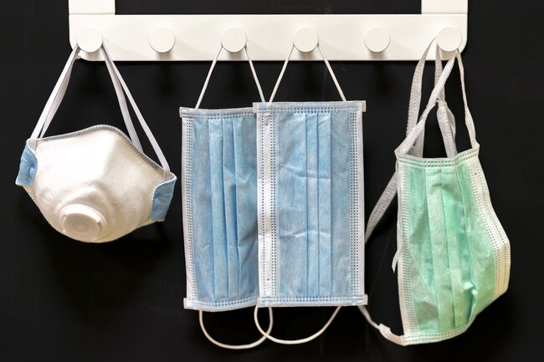

That said, you may find yourself in other situations that make wearing a mask while driving a good idea. For example:

* If you’re in the car with people who do not reside with you (in this case, it might be a good idea to avoid using the “recirculation” setting on your air conditioner or to open the car windows for air circulation)
* If you’re sick and have other people in the car
* If you feel anxious about being out in public right now, and keeping a mask on comforts you
* If you’re traveling a short distance between stops and don’t want to take the mask off only to have to put it back on again immediately

Since it’s generally a good idea to avoid touching your face mask (because it might be germy), it makes sense to just leave it on for a while instead of taking it on and off frequently. But if you do drive with it, understand that wearing a mask can reduce your field of vision. Always weigh the benefits of wearing a mask in your car against the potential risks involved.

Basically, when it comes to mask-wearing, think of your car as an extension of your home: Would you wear a face covering in your living room? You might – if a repairman had to come in to fix your electrical wiring or something. But most of the time you would not wear a face mask inside your house, and you can use the same thinking to decide if you should don a mask in the car.